A PROJECT REPORT ON

(Design and develop webs Based Applications for Healthcare Management)

By (EMAN YAQOOB AL-RAISI, 19f19350)

Guided by

(PUTTASWAMY MALALI)

A Project report submitted in partial fulfillment of the requirements for the award of

Community) in (Department of Computing))

Knowledge Oasis Muscat, Muscat, Oman

Spring 2023

A PROJECT REPORT ON

(Design and develop webs Based Applications for Healthcare Management)

By (EMAN YAQOOB AL-RAISI, 19f19350)

Spring 2023

**DECLARATION**

I, “EMAN YAQOOB AL-RAISI”, hereby declare that the work presented herein is genuine and has not been copied in part or in whole from any other source except where duly acknowledged. As such, all use of previously p u b l i s h e d work (from books, journals, magazines, internet, etc.) Has been acknowledged within the main report to an item in the references or bibliography lists. Copyright Acknowledgement I acknowledge that the copyright of this project and report belongs to MEC.

EMAN YAQOOB AL-RAISI, 19f19350

**APPROVAL FORM**

The project report entitled Design and developed webs Based Applications for Healthcare Management

Submitted by EMAN YAQOOB AL-RAISI, 19f19350.

Is approved in partial fulfillment of the Requirements for bachelor's degree in computer science.

--------------------

Supervisor Full name:

Department Date:

--------------------

Examiner Full name:

Department Date:

**ACKNOWLEDGEMENT**

The writer desires to express his/her most sincere appreciation and thanks to everyone who helps him for his encouragement and advice through the course of this study and for his help in the preparation and writing of this report. Thanks go to the faculty members of the Department of Computing and to the Head, Faculty of Computing, for supplying the source of information for this work. Thanks, are also due to Supervisor for successfully guiding the project work towards its completion.

I would like to thank the able Mr. PUTTASWAMY MALALI for always helping with the project from the beginning of this semester until the end. If it were not for his efforts, I would not have arrived here today.

I thank the Director General of the Ministry of Higher Education, Dr. Yacoub Al-RAISI, for helping in all aspects, especially in the field of website design.

**ABSTRACT**

My idea includes many things that society needs in just one website.

 1- donate health equipment to hospitals or an individual with special needs.

An example of it: Wheelchair, Health devices and others. There are people who do not have money, but he must attach the health papers, and then he goes to receive the device.

2- dates of blood donation and which hospitals to donate the blood.

Some days there is anemia and campaigns are launched to donate blood, but this website helps on a weekly basis by requesting blood groups to donate at the nearest hospital.

3- To search for the name of the medicine, meaning that if a person has a drug and cannot know it, he searches in this box, and it is a detailed explanation of the drug.

4- all hospitals in Muscat.

If the person does not know the location of the hospital, this website helps him to find the nearest hospital in the area in which he is located.

5- Weekly newsletters and user awareness.

Awareness campaigns, intensive weekly publications for citizens to reduce diseases and follow healthy habits.

 6- Physiotherapy through videos and pictures to be applied at home.

Some people do not have time to go to natural treatments, this website helps them to get physical therapy at home through videos.

7- Information about healthy nutrition.

 An explanation of the ideal weight, the appropriate food for the individual, the amount of sugar intake per day, and others.

**Table of Contents**

Chapter 1 10-17

M1. Introduction: 10

M2. Problem Statement1: 10-12

.M3: Scope : 13-15

M4: Stakeholders: 16

M5: Interfaces 16

M6: Aims and Objectives 17

M7: Contributi on 17

Chapter 2 18-41

M1: Introducti on 18

M2: Similar work: 19-21

M3: Reviewing literature: 21-34

M4:Feasib ility Analysis: 35-41

Chapter 3 42-81

M 1 Introduction: 42-43

M2: SWOT Analysis for Methodology: 44-45

M3: Justifying methodology: 45-52

M4: Applicatio n methodology: 52-58

M5: Project Planning: 59-66

M6: Data collection and analysis 67-70

M7: Requireme nts 71-76

M8: Illustratio ns 77-82

Reference: 83-85

Appendices: 84-91

**LIST OF ABBREVIATIONS**

|  |  |
| --- | --- |
| FAQs | Frequently Asked Questions |
| CSS | Cascading Style Sheets |
| BTS | Blood Transfusion Services |
| JS | JavaScript |
| HTML | Hypertext Markup Language |
| ML | Machine Learning |
| OMIC | Online Pharmaceutical Data for Citizens |
| SWOT | Strengths, Weaknesses, Opportunities, and Threats |
| MCI | Mild Cognitive Impairment |
| FDA | Food and Drug Administration |
| RAD | Rapid Application Development |
| WBS | Work Breakdown Structure |
| DSDM | Dynamic Systems Development Method |
| MVP | Minimum Viable Product |
| UI | User interface |

**Chapter 1:**

**M1: Introduction:**

Every year medicine develops from better to better to meet people's needs and discover new drugs to treat diseases. With the development of the world, everything has become through Internet technologies, and hospitals have become using everything exclusive, such as techniques and devices, to diagnose the patient correctly. Today's medicine world has become easier than ever through mobile phones. In European countries, websites were designed to track human health via mobile phones, and it was greatly beneficial, and this is the motivation to make me design this website for my country. Also Recently, some accidents and diseases increase in the country, and because of this, there is a large consumption of the blood bank store and health tools, and the target group increases more than before therefore, We will do a project that includes several bounties the increases community awareness and facilitates blood donations, health tools, weekly news, and physiotherapy treatments also, We will add calculate the weight and height of a person, and then the ideal weight, excess fat, and others will be included on it. This project benefits the community in their daily lives for their health. Our website serves as a powerful tool to address healthcare challenges, promote well-being, and facilitate connections between individuals, healthcare services, and resources. By harnessing the potential of technology, we aim to create a supportive and informative online environment where individuals can access the assistance they need, educate themselves about healthcare-related topics, and actively contribute to improving the lives of others. (Health, 2022)

**M2: Problem Statement:**

Recently, blood donation campaigns have spread in all governorates because there is a severe shortage in the store, and it increases day by day for the target group, and this requires an increase in blood but how can the appropriate blood be brought to the targeted people? I will design a website to help target people in addition, I will develop the site and add 7 bounties. Anyone can enter through this site and choose the appropriate option for him.

General Problem: The healthcare sector faces numerous challenges that hinder the well-being and quality of life of individuals. These challenges include blood shortages, limited access to health equipment, lack of medicine knowledge, difficulty in locating hospitals, low awareness about preventive care, limited access to physiotherapy, and inadequate knowledge about healthy nutrition. These issues contribute to compromised healthcare services, delayed treatments, and reduced overall well-being for individuals.

Specific Problems:

1-donate health equipment to hospitals or an individual with special needs.

An example of these: Wheelchairs, Health devices, and others. Health tools are very expensive, and a group of people do not have enough money to buy health tools to care for their patients, and hospitals cannot buy for all patients because it is very expensive but this website, it helps people to obtain health tools without sums of money, meaning some businessmen can buy health tools, and then they are placed in this website for the benefit of needy people but how is it ascertained if the patient is in need or not? Attaching sealed medicine papers from the hospital indicates that he needs health tools. After approval of the papers, he goes to receive the item required.

2-dates of blood donation and which hospitals to donate the blood.

Too many daily accidents, a person loses a lot of blood, and some people have anemia and need it urgently daily and some days there is anemia and campaigns are launched to donate blood, but this website will be requesting every week for the groups blood groups to donate to the nearest hospital. Also calling the factions that do not have blood helps to educate people to donate in the nearest possible branch, and it also helps to obtain the largest blood daily.

3-Search for the name of the medicine:

meaning that if a person has a drug and cannot know it, he searches in this box, and it is a detailed explanation of the drug. Many people, especially the elderly, have a lot of medicines, and sometimes it is not possible to know the medicine and why it is used this website has a place to search for the name of the drug, and then it comes in detail about the drug and for what purpose it is used for.

4-Location for all hospitals in Muscat.

If the person does not know the location of the hospital, this website helps him to find the nearest hospital in the area in which he is located For example visitors come continuously to Muscat to shop and enjoy it, and one of the visitors may have a high fever or faint, and others, so this website guides them to the nearest hospital that they can visit.

5-Weekly newsletters and user awareness.

Awareness campaigns, and intensive weekly publications for citizens to reduce diseases and follow healthy habits. Also, to educate them to donate blood and how to eat it healthily and properly, to limit the spread of obesity, and to educate the citizen about everything new about their health.

6-Physiotherapy through videos to be applied at home.

Physiotherapy is done daily to improve faster, but sometimes it is tiring for the patient to go to the hospital, or he may have difficulty getting him to the hospital and sometimes he does not have a car to transport him to the hospital daily. This website displays all the treatment and how it is implemented correctly and at home.

7-Information about healthy nutrition.

An explanation of the ideal weight, the appropriate food for the individual, the amount of sugar intake per day, and others. Meaning certain people who suffer from obesity and do not have the amounts to follow health programs, but this website helps to reduce a person's weight, meaning when setting height and weight, what is extra in the body and how to reduce weight and follow healthy habits.

These specific problems collectively impact the overall healthcare landscape and hinder individuals' access to essential services, proper care, and a healthy lifestyle. Addressing these challenges through targeted interventions and innovative solutions is crucial to improving healthcare outcomes and promoting the well-being of individuals.

**M3: Scope:**

design this site for people who do not have enough money to buy healthy and sound tools so that they can get everything new and exclusive to start treatment, increase the number of blood bags to cover all the needs of people, and educate people to follow healthy habits and leave everything that harms people, such as obesity, drugs, alcohol, and others. Also, to reduce weight, eating in a way that suits the body, and reducing body fat.

design the website starting from October until February, meaning it takes about 5 months to design and implement the website in the first stage, the project is planned, how it will look, how it will be implemented, which programs after planning will be implemented gradually, and which methods are appropriate to complete the project. After that, there are 7 options on the site, and when an option is finished, an examination is made to make sure it works correctly or not, and this is how the project is completed, and the time does not exceed 5 months.

|  |  |  |  |
| --- | --- | --- | --- |
| **Total cost** | **Cost** | **hardware\Person\software** | **Quantity** |
| 900 RO | 300 RO | computer | 3 |
| 1300 RO | 650 RO | software developers | 2 |
| 700 RO | 700 RO | Designers’ developers | 1 |
| 700 RO | 700 RO | security web application | 1 |
| 200 RO | 200 RO | News releases | Many time |
| 1000 RO | 500 RO | website tester | 2 |
| 4800 RO |

A cost-benefit analysis (CBA) could be a precise strategy utilized to assess the costs and benefits associated with a venture, venture, or choice. Within the setting of a website, a cost-benefit examination tries to look at the money-related and non-financial suggestions of building up, working on, and keeping up the site.

We must weigh the website's potential advantages against its expected costs to conduct a cost-benefit analysis. The website may result in higher sales, greater client retention, and lower operational costs.

Here are some potential benefits of the Website:

1. Increased Blood Donations: Blood donation drives are started on some days when there is a need; however, this website offers weekly assistance by asking blood types to be donated at the nearby hospital. As a result, it will be simple to obtain, which will raise usage of this site and demand for it, which could result in a rise in money.
2. Cost Savings: People can acquire sanitary products on a website with no financial strain, which will cut down on their costs. Additionally, allowing donations rather than outright purchases may have an impact on hospital expenses.
3. Improved user experience: The website's capacity to deliver a user-friendly interface, simple navigation, and as a result, the impact will be felt in terms of user involvement, pleasure, and return visits, as well as the possibility of good word-of-mouth and enhanced user confidence.
4. Public Health Impact: Public Health Impact: The broader impact on the public health of a site and the prospect of raising awareness and educating people about health-related topics, supporting healthy habits, and minimizing the spread of diseases.

By completing a cost-benefit investigation, we are ready to look at the site's overall worth and reasonability. Whereas a few benefits may be difficult to measure financially, the inquiry makes a difference in direct decision-making with respect to the website's development and subsequent upkeep. It is vital to analyze both the costs and benefits to establish the reasonability and conceivable impact of the site in achieving its destinations.

**The software used:**

Visual Studio code will be the editor that I will use in my project … Starting from the most important things that are very important in web development is the front end, which will be HTML & CSS & php are the basic techniques that I use in front-end development. In the same visual studio code editor, I will write the mother language of the project. On the other hand, databases are also a crucial aspect of developing web applications. We use the database to store and retrieve data. In this aspect, I will use phpMyAdmin to create the base and run or activate the server and base data with XAMPP.

What distinguishes this site is that it publishes weekly news about health to challenge diseases and increase people's awareness, Showing weight and height, calories, excess fat, etc. A system that benefits people who are treated with physiotherapy, they can follow up their treatment from home through videos and pictures, Once the name of the pills is put, all information about the pills, their contraindications, harms, and benefits will be revealed. Increased blood bags and no need to launch donation campaigns, also obtaining health tools for all those in need for free, once papers from the hospital are attached.

**M4: Stakeholders:**

A stakeholder is any individual, group, or entity that has an interest or concern in a particular project, organization, or system. Stakeholders can be affected by the outcomes or decisions related to the entity in question. They may have varying levels of influence, involvement, and significance depending on their relationship and the context in which they operate.

**Table 1:**

|  |  |  |  |
| --- | --- | --- | --- |
| NO | Stakeholders | Int/Ext | Their impact |
| **1** | website development team | Int | They are the people who will develop and maintain the website, and everyone has a role in creating this website, including the project manager, programmers, designers, and others. |
| **2** | The organization or the Ministry of Health | Int | the entities that will be affected by the website and have an interest in this website. |
| **3** | website Testers | Int | They are the ones who test the website for the last time, for example, employees, the project manager, and the organization. |
| **4** | People or customers | Ext | They are the ones who use the website to benefit from it. |
| **5** | Organizations | Ext | In the sense that there can be an agreement or cooperation between the organization and the work team to integrate products between them. |
| **6** | Volunteers | Ext | This includes people who donate blood or sanitary ware, as well as organizations and companies that donate. |
| **7** | Organizers | Ext | They are the organization that organizes and arranges the site |

**M5: Interfaces:**

This site will be available on the web. The person can open this site by phone (Chrome Browser, H Browser, etc.) and by laptop and iPad.

**M6: Aims:** This project aims to leverage technology and compassionate support to address critical healthcare challenges, empower individuals, and promote a culture of well-being. By providing accessible resources, promoting awareness, and facilitating connections between individuals and healthcare services, we strive to make a positive and lasting impact on the lives of individuals and communities.

**M6: Objectives:**

1. Facilitate the donation of health equipment.
2. provide medicine information.
3. Provide home-based physiotherapy guidance.
4. Share information about healthy nutrition.
5. Weekly newsletters and user awareness.

(Astrup, 2001)

**M7: Contribution:**

This website will sensitize all people to live healthy and disease-free. This website will expand day by day and become more used.

**Chapter 2:**

**M1: Introduction:**

We are excited to introduce the web, a cutting-edge initiative designed to increase public awareness and promote a sense of good attitude. The entire platform includes a few elements that will fundamentally alter how people interact with their health and make informed lifestyle decisions. We are dedicated to supporting people in their pursuit of a healthier and happier life by integrating cutting-edge technology, interactive tools, and invaluable resources.

A chain of rewards that reward and promote blood donations—a lifeline for many patients in need—lies at the project's core. We sincerely hope that by cultivating a group of kindhearted people who actively take part in this vital action, we may significantly improve the condition of people who are dealing with medicine issues.

The stage goes past blood gifts, advertising a run of well-being apparatuses that cater to differing needs. With an accentuation on individual well-being, we have consolidated progressed fake insights calculations to calculate and give fundamental measurements such as weight, stature, and perfect weight. Also, the framework investigates body composition, counting overabundance of fat, permitting clients to pick up profitable experiences into their in general well-being and make educated choices around their wellness objectives.

The Community Wellbeing Center isn't a store of data but a position of motivation. I get the significance of remaining up to date with the latest advancements within the well-being and Ailment industry. In this way, I curate and distribute week after week news, bringing you the foremost important and quick articles, ponders, and expert conclusions. By engaging the community with information, I point to assist people to overcome corpulence, embrace sound propensities, and explore the complexities of a health-conscious way of life.

Since I esteem a person's general well-being, I've moreover included physiotherapy administrations in the stage. Clients get to focus on proficient approaches to address physical confinements, recuperate from wounds, and upgrade their by and large portability through guided works out, recordings, and proficient help. The objective is to guarantee that everybody can have a dynamic way of life and make strides in their physical well-being by democratizing get to master physiotherapy.

(Realdon et al., 2016)

Eventually, the Community Wellbeing Center is driven by energy for changing lives and making a more beneficial society. By leveraging the control of innovation, I look for to rouse positive alter and bolster people in their topic towards ideal Ill-being. Connect us in this unimaginable endeavor as I construct a community that grasps sound living, cultivates mindfulness, and elevates one another. Together, I can make a genuine contrast between the lives of people and the well-being of the community.

**M2: Similar work:**

For my project, background reading may cover a range of subjects such as community awareness, blood donations, medicine devices, Ikey news and physical therapy procedures. The following ideas for enhancing my prior reading with appropriate textual references are provided:

1. Community Awareness and Blood Donations:
   * Perused almost the significance of community mindfulness in advancing blood gifts and its effect on open well-being. Consider alluding to things about or articles that examine the part of involvement in the community in expanding blood gifts and tending to blood deficiencies (Smith, Johnson, & Anderson, 2019).
   * Analyze the highlights, viability, and client encounters of the current frameworks or stages that have effectively upheld blood gifts in communities (Lee et al., 2020).
2. Health Tools and Physiotherapy Treatments:
   * For keeping tabs on your health, learn about the numerous technologies at your disposal, such as health monitors, website applications for diet surveillance, or Arable devices for rehabilitation.

(Mendiola et al., 2021).

* + Look at the focal points and adequacy of the different physiotherapy treatment modalities that are habitually utilized for restoration and recuperation (Wang et al., 2020).

1. Obesity Awareness and Healthy Habits:

Learn more about the growing incidence of being overweight, the health hazards it poses, and the significance of increasing the general understanding of this problem.

(Ng et al., 2014).

* + Investigate and Examine procedures for advancing sound propensities and avoiding weight, counting instructive campaigns, community intercessions, and behavioral alter procedures (Acharya et al., 2019).

Here are a few comparable applications for an extent that incorporates bounties to extend community mindfulness and encourage blood gifts, well-being instruments, Ikey news, physiotherapy medications, and manufactured insights to calculate Light and tallness:

1. Health Tap: allows consumers to ask free health inquiries to a network of U.S. licensed doctors online and via mobile devices.

2. MyPlate by Livestrong: The MyPlate Arrange appears your nourishment gather targets – what and how much to eat inside your calorie stipend. Your nourishment arrangement is personalized, based on your: Age, Gender, Tallness, Weight, and Physical movement level.

3. Blood Donor: The American Ruddy Cross made an app that empowers clients to see adjacent blood drives and gift areas, track their history of gifts, and get cautions when their blood sport is in tall request.

4. MyFitnessPal: MyFitnessPal is one of the leading weight misfortune apps and wellness apps, making a difference in about 1 million individuals reaching their sustenance and wellness objectives each year. Individuals utilize it as a calorie tracker and calorie counter to log their nourishment and take advantage of the app’s nourishment database which contains over 14 million nourishments. It’s not fair a free calorie counter app — it’s too the most excellent calorie counter app for individuals who are looking to require back control of their well-being and wellness.

5. Healthline: an online site that offers careful well-being data, counting news, suppositions from specialists, and devices for overseeing medicine conditions. Healthline is here for the full person—for your whole life—so we cover all viewpoints of physical and mental well-being in a legitimate, impartial way.

6. Headspace: a portable website that provides guided mindfulness and reflection hones to assist clients to unwind, rest superiorly, and feel way better in general. Headspace helps you in shaping life-changing propensities to back your mental well-being and find a more advantageous, more joyful you with science-backed mindfulness and intervention methods.

**M3: Reviewing the literature:**

The goal of this study is to develop a project that facilitates blood donations, health tools, weekly news, and physical therapy therapies while also raising community awareness. This project's main objective is to help the neighborhood by encouraging healthy behaviors, battling obesity, and increasing understanding of the value of routine blood donations.

Objective 1: Facilitate the donation of health equipment.

Sources:

The article “A Framework for a Smart Social Blood Donation System Based on Mobile Cloud Computing” clearly relates to the concept of my project, which is for the sake of saving lives, blood donation and blood transfusion services (BTS) are essential. The utilization of social media and web applications to advance blood gifts, offer supplementary administration and make communities around blood gift centers has as of late been endeavored on a worldwide scale. Blood banks regularly have blood deficiencies, which leads to social media campaigns empowering solid people to give blood to patients who critically require blood transfusions. Increment the number of individuals who give blood by building up centered mindfulness campaigns, community outreach activities, and key organizations together with organizations to illuminate and persuade individuals to provide blood on a customary premise. And Make strides the benefactor travel by streamlining the enrollment handle, making strides in the arrangement planning forms, and advertising a user-friendly online stage that empowers givers to rapidly find adjacent blood gift offices, check their qualifications, and keep track of their gift history. improve viable blood conveyance Make a careful framework to screen blood requests and stock in real-time, guaranteeing viable conveyance to clinics and healthcare offices. Optimize the conveyance of blood units based on request and geology by utilizing intelligent calculations and information investigation. making strides in benefactor instruction Provide careful points of interest approximately the centrality of blood gift, the gift strategy, qualification prerequisites, and well-being points of interest. To scatter common misguided judgments and illuminate potential donors around the effect of their endowments, give guidelines materials, FAQs, and intelligent apparatuses. Mostafa, A. M. (2014, December 23).

Objective 2: Provide medicine information.

Sources:

The article “Online Medication Information for Citizens: A Comparison of Demands on eHealth Literacy” clearly relates to the concept of my project, which is for A lot of people use prescription medications, thus they require knowledge of the risks and advantages of doing so. Increasingly individuals are turning to the web for health-related data, especially subtle elements on drugs. On various websites, you'll discover Online Pharmaceutical Data for Citizens (OMIC). This ponders compared six of these destinations utilizing the Wellbeing Proficiency Online (HLO) Checklist as a system. We moreover carefully assessed the cosmetics of each OMIC for three distinctive drugs. We were able to distinguish a number of the websites' points of interest and impediments in terms of how they were created and composed, as well as their appropriateness for clients with a moo degree of eHealth proficiency.

On the off chance that you're taking a medication but are uncertain of what it is, sort the title of the medicine into the look field to see a nitty gritty portrayal of it. This program offers a put to see up the title of the drug, and after that, it gives data on the sedate and its aim to utilize. Numerous individuals, particularly the elderly, take various drugs, and it is sometimes incomprehensible to distinguish the sedate and its planning utilization. (Lemonlionheart, 2015)

By giving buyers exhaustive and dependable data concerning pharmaceuticals, we trust to supply them with the knowledge and comprehension they got to effectively lock in their healthcare choices. This empowers understanding independence and inclusion by enabling individuals to form learned choices almost their pharmaceutical. Clients who are new to a specific drug's work, dose, potential unfavorable impacts, and intuition can take advantage of exact pharmaceutical data. This data brings down the probability of negative side impacts, medicine botches, and potential harm from wrong pharmaceutical utilization. By making medicine data effortlessly open online, individuals can get data on their medicine solutions at whatever point it's helpful for them.

Typically, particularly accommodating for those who might have inconvenience getting too careful pharmaceutical data or may have limited get to restorative pros. Instruction: Giving clarifications and depictions of medicines and their applications helps individuals in understanding the focal points and potential dangers of their treatment, particularly the elderly and those with moo well-being proficiency. In turn, this energizes individual responsibility and dynamic support in well-being administration. The site, made in collaboration with Solid, makes a difference in restorative practitioners' endeavors to teach patients by giving exact medication data. It improves the part of the healthcare specialist by emphasizing basic data concerning drugs, coming about in way better patient-provider interaction, and expanding compliance with treatment.

Avoidance of Pharmaceutical Abuse: The site empowers fitting pharmaceutical hones by drawing consideration to potential dangers, contraindications, and suggested doses. Clients can get to be more learned approximately conceivable sedate intelligence, security measures, and notices, bringing down their chance of manhandling or abusing solutions.

(Lemonlionheart, 2015)

Objective 3: Provide home-based physiotherapy guidance.

Sources:

The article “Technology-enhanced multi-domain at the home continuum of care program concerning usual care for people with cognitive impairment: the Ability-Telerehabilitation study protocol for a randomized controlled trial” clearly relates to the concept of my project, which is for 46.8 million individuals worldwide are currently living with dementia, according to the World Alzheimer Report (Prince, The Global Impact of Dementia: an Analysis of Prevalence, Incidence, Cost and Trends, 2015). By 2050, this population is predicted to reach a high of over 131.5 million, placing a greater strain on society and families. The absence of effective medicine therapies for dementia has shifted attention to nonpharmacological approaches and psychosocial therapies for those who have or are at risk for dementia, such as those with Mild Cognitive Impairment (MCI). The current study's objective is to evaluate a multifaceted, home-based, personalized program for people with MCI and outpatients who are in the early stages of dementia. Accessibility, by providing home-based physiotherapy guidance, the website ensures that individuals have access to rehabilitation resources regardless of their location or mobility limitations. This promotes inclusivity and eliminates barriers to receiving necessary physiotherapy care.

With home-based physical treatment, patients can total their restoration at their claim pace without having to form various clinic visits or depend on exterior transportation. Due to their capacity to fit treatment into their regular plans, patients are more likely to follow their treatment plans and accomplish way better long-term comes about. Giving enlightening for doing physiotherapy exercises at domestic empowers patients to require a charge of their possess recuperation. People can progress by and large in quality of life, pick up control over their physical well-being and create more certainty by learning the information and abilities essential to oversee their treatment on their claim. Especially for individuals with moo budgetary implies or restricted access to healthcare offices, home-based physiotherapy may be a more reasonable choice than in-person arrangements.

The site makes a difference in individuals dodge pointless treatment costs and energizes self-sufficiency in taking care of their restoration by advertising exhortation and apparatuses. Based on one-of-a-kind requests, issues, and advances, the site can give customized physical treatment counsel. By making treatment more individualized, patients are certain to get works out and approaches that are appropriately adapted toward their specific restoration objectives. Care Progression, Physiotherapy supervision given at domestic advances coherence of benefit indeed between planned therapy sessions. In arranging to preserve their physical well-being over the long term and maintain a strategic distance from backslides, patients can proceed with their recovery advance between arrangements or after wrapping up their suggested treatment program.

Realdon, O., Rossetto, F., Nalin, M., Baroni, I., Cabinio, M., Fioravanti, R., Saibene, F. L., Alberoni, M., Mantovani, F., Romano, M., Nemni, R., & Baglio, F. (2016).

(Kimanh, 2017)

Objective 4: Share information about healthy nutrition.

Sources:

The article “Healthy ways of life in Europe: the anticipation of corpulence and sort II diabetes by eating less and physical activity” clearly relates to the concept of my extent, which is for One of the speediest spreading maladies, corpulence influences 10–40% of the grown-up populace within the lion's share of EU-countries and is on the rise over all age categories. Corpulence raises the hazard of major co-morbidities such sort 2 diabetes, cardiovascular infection, a few malignancies, and a shorter life hope; these issues may be dependable for 5–10% of add up to restorative costs in EU countries. Weight in specific raises the chance of diabetes, and weight and overweight with a stomach fat conveyance are dependable for 80–95% of the rise in diabetes. An energy-dense, high-fat slim down, and dormancy are autonomous chance components for weight pick up and corpulence, concurring to solid proof from cross-sectional and longitudinal inquiries. Also, dietary fat and physical fitness are connected to set up fat adjust, which increments the impact of a high fat eat less in causing weight in defenseless patients, particularly in stationary individuals with a hereditary inclination to corpulence. Astrup, A. (2001).

Information and Mindfulness: The site endeavors to raise people's information and mindfulness of the esteem of adjusted suppers, critical supplements, fitting parcel sizes, and the impacts of nourishment choices on common well-being. Typically done by giving data around sound nourishment. This gives individuals the control to select their eating propensities with information.

Data from almost solid nourishment makes a difference in individuals get how great nourishment choices can avoid and oversee an assortment of well-being concerns, such as corpulence, diabetes, heart infection, and other constant ailments. To reduce the risk factors for various diseases, increasing the use of an adjusted slim down is important.

Way of life Alter: Dispersing valuable information around a sound slim down spurs individuals to create a long-lasting way of life alterations. The site makes a difference in individuals altering their eating propensities for the superior over time by giving counsel on supper arranging, formula proposals, and pointers for working nutritious dinners into regular schedules.

Individualization: Given that each person's dietary needs are interesting, the site can offer custom-fitted exhortation depending on things like age, sexual orientation, the sum of movement, and specific dietary choices. This methodology ensures that individuals get specialized direction and help for their specific dietary needs.

All-encompassing Well-being: The site can give data on the focal points of suitable nourishment for mental well-being, vitality levels, immunological work, and in general essentialness, with an accentuation on the association between sound nourishment and add up-to well-being. The site helps individuals in getting their most extreme physical and enthusiastic prosperity by supporting an all-encompassing approach to nourishment.  
Commonsense Counsel: The site can give valuable exhortation, sources, and devices to assist individuals adopt healthy eating propensities. This may incorporate menu arranging worksheets, basic supply records, suggestions for wholesome formulas, and strategies for overcoming ordinary deterrents to eating well.

Astrup, A. (2001).

Objective 5: Weekly newsletters and user awareness.

Sources:

The paper "Realistic Outcomes: Lessons from Community-Based Research and Demonstration Programs for the Prevention of Cardiovascular Diseases" is straightforwardly important to the thought of my venture, which is for the American Heart Affiliation. The center of any effective program is community organization preparation. This requires finding and enrolling critical community pioneers, propelling individuals, and organizations to volunteer their time and cash for CVD avoidance and advancing anticipation as a social cause. To advance well-being, an assortment of mediation settings can be utilized. Compared to the working environment, churches are agreeable to well-being advancement exercises and have got to a sizable group of onlookers. Mass media are most compelling when utilized in conjunction with complementary messages dispersed through other channels, such as school programs, grown-up instruction programs, and self-help programs. Community wellbeing experts need to bolster activities and advance interest from other nearby pioneers. Through school-based activities that effectively include guardians in expansion to kids, long-term behavior alteration is bolstered. Imaginative well-being advancement competitions are well-liked and rouse interest in other neighborhood ventures.

Instruction and Strengthening: The site endeavors to teach and enable individuals by spreading reliable, fact-based data on an assortment of health-related points through the week-after-week bulletins it disseminates. Clients are given the data they ought to make learned choices, take proactive measures to move forward with their well-being, and effectively lock in self-care.

Infection Avoidance: The newsletters' fundamental objective is to extend open information of early discoveries, preventative measures, and way-of-life changes that can help lower the chance of various maladies. The site endeavors to teach clients about hazard components, screenings, solid propensities, and immunizations to energize them to receive preventive measures and make superior choices. Mittelmark et al. (1993)

Sound Propensities and Way of Life: To empower the appropriation of sound propensities and way of life hones, the pamphlets will offer supportive exhortation, suggestions, and strategies. This could incorporate substance on workout regimens, stress-reduction methodologies, dietary suggestions, rest cleanliness, and other subjects that progress common prosperity.

Keep Up to Date: The bulletins will keep peruses up to date on all recent progressions, revelations, and changes within the healthcare industry. The site endeavors to keep peruses up to date on the continually changing environment of healthcare by spreading overhauls on restorative propels, modern treatment choices, developing well-being patterns, and relevant news.

Community Engagement: By advancing client engagement, comment, and inclusion, the pamphlets will create a sense of community. This could be fulfilled by incorporating intelligent components like Q&A sessions, client stories, victory stories, and the trade of declarations or individual encounters relating to well-being and prosperity. The site tries to create a dynamic and empowering community where clients may trade information and encounters.

Behavioral Alter: The site endeavors to advance positive behavioral alter by reliably and mindfully conveying well-being data through week-by-week emails.

 The bulletins will work as a provoker and help clients to create more advantageous behaviors, accomplish their well-being objectives, and keep a proactive state of mind toward their well-being.

Mittelmark et al. (1993)

This ponder is critical since it bargains with a few crucial community health-related themes. The project to begin with objective is to energize solid hones and raise community information on health-related concerns. Usually, fundamental today since inactive propensities and destitute eating propensities have multiplied, expanding the predominance of constant ailments counting diabetes, heart infection, and weight. This venture can help individuals in making strides they’re by and large well-being by advancing sound propensities and allowing them to get to well-being assets and rethemes.

Any inquiry about thinking about must incorporate a chapter on the writing audit since it offers a basic evaluation of the body of information as of now composed on the subject being examined. The segments of a commonplace writing survey chapter are as takes after:

Introduction: In this section, the research problem, its importance, and the goal of the chapter on the literature review are briefly discussed.

The parameters of the literature review are specified in this part, along with the standards by which the material for the study was chosen.

Methodology: The techniques used to perform the literature review are discussed in this section, including the databases and search phrases used to find pertinent studies.

The findings from the evaluated literature are summarized and categorized in this section's synthesis of the literature.

This section offers a critical critique of the reviewed literature, pointing out any gaps, contradictions, or restrictions.

Implications and suggestions of research problems, we address the practice recommendations, identify areas for further research, and analyze the implications of the studied literature for the research problem.

And Conclusion: This section emphasizes the literature review's contribution to the research study, explains its main outcomes, and reaffirms the study's goal.

An introduction, procedure, synthesis of the literature, critical analysis, implications and suggestions, and conclusion are usually included in a chapter on literature reviews. Together, these parts offer a thorough review of the body of scholarship on the subject issue.

The extent moreover points to empowering visit blood gifts. Lifesaving blood gifts are basic, particularly in times of emergency and misfortune. In any case, due to an assortment of myths and stresses, numerous individuals are still reluctant to give blood. Tending to these issues and empowering more people to provide blood habitually, extends trusts to extend the supply of blood for those in require.

Any investigation think about must incorporate a chapter on the writing audit since it offers a basic evaluation of the body of information as of now composed on the subject being examined. The areas of a normal writing audit chapter are as takes after:

1. Qualities: List the project's major resources, such as its capacity to make strides in community wellbeing, its creative utilization of innovation (such as manufactured insights), and its accentuation on empowering sound ways of life and standard blood gifts. Moreover, take into consideration the project's greatness, reasonability, and probability of victory.

2. Shortcomings: Distinguish the project's potential shortcomings, such as the need for aesthetics (counting subsidizing and staff), potential moral issues (such as the protection and privacy of well-being information), and the plausibility that the extension will prohibit a few bunches (such as those without get to innovation or those who may be doubtful of blood gifts).

3. Commitment: Consider how the activity might include the body of information on community wellbeing. Based on the noteworthiness of empowering solid behaviors and standard blood gifts, as well as the utilization of innovation to move forward well-being results, consider if the venture asserts, expands, or challenges the body of existing information.

4. Make comparisons between the extent and other activities that have also tended to community well-being and innovative utilization. Take into consideration how the project's strategy and expectations come about compared to those of other things and whether the activity offers new points of view on how to unravel community wellbeing issues.

5. Future activities: Take into consideration the project's results for up-and-coming hands-on work. Decide the zones that require extra thinking about and development in arrange to fill in any crevices or limits within the current body of information and to explore modern lines of request.

A project's merits and blemishes, potential commitment to the body of writing, comparison to other activities, and distinguishing proof of zones in require of encourage consideration and development are all portions of the assessment preparation.

A few conceivable gaps and limitations that may be helped incorporate: Get to innovation: Since the project's accentuation on utilizing manufactured insights and innovation to calculate body Light and perfect Light, a few individuals may not have an introduction to or cannot bear these esthetes. This might anticipate a few bunches from picking up from the venture. Blood gift: Even though the extension tries to raise open awareness and empower blood gifts, it does not address potential impediments to gifts, such as fear or shame related to blood gifts or the need for gift centers. By tending to these issues, the project's impact may be encouraged and expanded. The project's contract accentuation on a specific gather or zone may make it less generalizable to other individuals or circumstances.

It's crucial to think about how the project's findings and results could be used in different contexts. Ethics-related factors Concerns about security, anonymity and the gathering of health data. To protect the rights and well-being of individuals, the project should make sure that these factors are effectively considered. Sustainability: After the project's first implementation, it should still be viable. This could involve figuring out potential financing sources, developing ongoing data gathering and analysis methods, and developing plans to guarantee the project's continued viability and long-term impact.

Here are some prospective study topics that might be investigated:

. 1. Evaluation of the project's effectiveness: A formal assessment of the project's success in attaining its stated goals could offer crucial information on how the project will affect the results of community health.

2. Long-term follow-up: Analyzing the project's effects after its first deployment could shed light on its viability and the likelihood that it will continue to have an impact on community health.

3. Fitting the venture to diverse populaces: By fitting the extent to other communities with diverse well-being needs and getting to innovation, it would be conceivable to broaden the initiative's scope and make it more appropriate to all individuals.

4. Exploring the utilization of other advances: Investigating the utilization of other innovations to empower solid behaviors and normal blood gifts, such as versatile wellbeing website or Inarable, may offer other ways for upgrading community wellbeing results.

5. Expelling deterrents to blood gift: Distinguishing and killing such deterrents, such as disgrace or fear, seem to boost blood gift rates and upgrade the project's effect on community wellbeing.

6. Evaluating the moral repercussions: A more careful examination of the ethical issues raised by the utilization of manufactured insights and the gathering of well-being data seems to help guarantee that the extent follows ethical measures and shields participants' rights and well-being.

To protect or move forward their well-being, individuals can utilize this data to way better get their current well-being state. The activity can convey solid and exact information on an assortment of well-being pointers with the utilization of manufactured insights, making it less complex for individuals to create taught choices almost how they are feeling.

**M4: Feasibility Analysis:**

Feasibility analysis, which entails determining if a project proposal is feasible and practicable, is a crucial component of project planning. Feasibility analysis comes in a variety of forms, including:

1. Specialized achievability investigation: This kind of possibility investigation assesses a project's specialized necessities, such as its equipment and program. For occurrence, the venture will require involvement in program advancement to develop the programs and assets required to raise mindfulness of blood gift and well-being. This will involve making a program to decide suitable weight, spreading news and overhauls, and streamlining blood gifts, among other things. To oversee the client information accumulated, the venture will require to get to the right adapt, such as servers and cloud-based capacity. This adapt must be able to handle the expected volume of user traffic and information capacity. To guarantee the security of client information, the venture will have to follow information security and security rules. To guarantee that data is properly gathered and processed, the project will need to be integrated with current healthcare systems and blood donation facilities. This will necessitate the adoption of suitable safety precautions, such as encryption and safe retention mechanisms.

**Table 2:**

|  |  |
| --- | --- |
| **Hardware** | **Function** |
| Computer | To evaluate web |
| Server | To retrieve information |
| Laptop | To developed web |
| IOS device | To evaluate web |

Top of Form

2. Economic viability analysis: In this kind of examination, the costs and advantages of a project's economics are evaluated.

* Development expenses: The project will have considerable up-front development expenses, such as software creation and hardware purchase. The project team will need to create a budget that takes development costs into account.
* Operating Costs: The project will need continuing expenses for operation, such as server and cloud storage fees, maintenance charges, and marketing and promotion costs to spread awareness of the project in the local community.
* Revenue Streams: The project may make money in a few ways, such as through collaborations with hospitals and blood donation facilities, advertisements on the website and subscription-based access to exclusive material.
* Community request: The degree to which the community is in require of the administrations given will decide the project's victory. The venture group will have to assess the imminent request to create beyond any doubt that the consumptions related to development and operation are advocated.
* Competition: The activity will confront competition from different stages that center on well-being and blood donation, counting as now accessible portable well-being apps and websites. The extended group will assess the showcase competition and make strategies to set the extent separated and draw clients.

|  |  |
| --- | --- |
| **ITEMS** | **COST** |
| Computer | 300 OMR |
| Microsoft Visual Studio Community | Free |
| Laptop | 290 OMR |
| IOS device | 450 OMR |
| Total | 1040 -1140 OMR |

(*Types of Feasibility Study in Project Management: Meaning, Purpose*, n.d.)

**Table 3**

2. Operational possibility investigation: This sort of investigation assesses the operational aspects of a venture, counting the impact on current priorities and strategies. The openness of the subjects will help the venture group decide whether they have the assets required to effectively total the venture. This comprises both human and specialized subjects, such as equipment and computer programs, as well as human subjects like developers, substance makers, and community chairmen. To ensure beyond any doubt that the services provided are in line with their targets and methods, the venture will work with current healthcare organizations and blood donation offices. The extended group will have to build connections with these firms and comprehend their needs and operational homes to do this.

The extension will have to be coordinated with existing healthcare frameworks and blood-gift centres to guarantee that information is legitimately collected and handled. This will require the extended group to work closely with these organizations to get their frameworks and forms.

**Table 4:**

|  |  |  |  |
| --- | --- | --- | --- |
| **Total cost** | **Cost** | **hardware\Person\software** | **Quantity** |
| 900 RO | 300 RO | computer | 3 |
| 1300 RO | 650 RO | software developers | 2 |
| 700 RO | 700 RO | Designers’ developers | 1 |
| 700 RO | 700 RO | security IBM application | 1 |
| 200 RO | 200 RO | News releases | Many time |
| 1000 RO | 500 RO | Website tester | 2 |
| 4800 RO |

**Table 5:**

|  |  |
| --- | --- |
| **Hardware** | **Function** |
| computer | facilitating data processing and analysis, building user interfaces, and distributing digital content. Without computers, it would be challenging to meet the objectives of the project efficiently and effectively. |
| Server | a server is vital for centralized information capacity, information security, versatility, accessibility, and centralized handling obligations. Without a server, it would be challenging to handle and prepare the tremendous sums of health-related information required for the venture and guarantee the project's steadiness and security. |
| Laptop | A portable workstation is fundamental for creating the website and offers more unwavering quality compared to a desktop computer due to its transportability and ease of transportation. |
| IOS device | The evaluation of the website on an iOS device is necessary to identify any bugs or other issues. |

1. Legitimate achievability examination: This sort of possibility investigation analyses the legitimate viewpoints of a venture, such as compliance with directions and laws. A lawful achievability investigation comprises analysing whether the venture is compliant with pertinent laws and directions. Here are a few concerns concerning the lawful possibility of the extension:

* Information security: The activity will assemble and prepare individual information from clients, such as their Light, stature, and blood gift history.
* Mental property: The extent may include the utilization of secured substances, such as photos and content, and may moreover require the improvement of restrictive computer programs. The venture group will have to guarantee that they have the desired consents to utilize copyright sources and secure them to possess mental property through licenses, trademarks, and copyrights.
* Advertising rules: The venture may win income through promoting, and the extended group will comply with important publicizing controls, such as the Government Exchange Commission (FTC) rules within the Joined together States.
* culpability: The venture may include giving health-related exhortation and data, and the venture group will have to survey their conceivable culpability for any hurt that will happen from the utilization of the project's administrations. This may require getting risk protections and drafting relevant warnings and client contracts.
* Administrative compliance: The venture may have to comply with a few administrative organizations, such as the Nourishment and Medicate Organization (FDA) within the Joined Together States or the European Drugs Organization (EMA) within the European Union, based on the administrations provided.

5. Plan possibility think about: This sort of achievability investigation analyzes the time and aesthetics required to achieve the venture. A timetable possibility examination involves deciding on the off chance that the venture can be completed within the required period. Here are a few variables for the planning achievability of the venture:

* Venture scope: The venture group must indicate the project's general parameters, counting all deliverables and due dates. This will make it less demanding to prove beyond any doubt that everybody within the group is working toward the same destinations, whose occupations are disseminated viably.
* Retheme accessibility: To decide whether there are sufficient rethemes, both human and mechanical, accessible to wrap up the venture by the target due date, the venture group must assess this calculation. To do this, a retheme methodology must be developed, enumerating all required rethemes and their accessibility.
* Assignment conditions: To form beyond any doubt that the venture timetable is practical and attainable, the extended group will be got to distinguish assignment conditions, such as work that cannot be begun until others are wrapped up. To do this, a careful venture arrangement that records all assignments and their conditions must be made.
* Chance administration: The extended group must recognize and reduce risks that seem to influence the timeline. For this, a hazard administration technique will be created that recognizes planned dangers, their probability and effect, and moderation strategies.
* Monitoring and controlling: The project team will need to keep an eye on how things are doing regarding the project timeline and make any necessary adjustments. Regular project status meetings, progress updates, and continuous collaboration will all be required for this.

(Team, n.d.-a)

A real achievability ponder for the venture would regularly include calculating the equipment, program, materials, and extra overhead costs required to total the project. This would include evaluating the costs and benefits of the venture and deciding whether the extension is financially reasonable and feasible. The thinking would also include evaluating the specialized, operational, legitimate, and plan achievability of the extent to decide whether it is common sense and achievable within the given imperatives.

**Chapter 3:**

**M1: Introduction:**

With the assistance of innovative, restorative, and counterfeit insights improvements, the Healthcare Management activity endeavours to extend community well-being, mindfulness, and healthcare available. We predict a stage that joins components like blood gift help, simply get-to-prudent wellbeing items, and week-by-week news upgrades on wellbeing mindfulness due to the growing reliance on web innovations and portable phones within the therapeutic industry. By utilizing manufactured insight calculations to compute vital well-being measures, such as weight, stature, and ideal weight, our activity goes beyond standard healthcare methods and empowers individuals to effectively screen their well-being.

We work to progress the community's regular lives and help in their travel towards progressed well-being by tending to critical issues such as over-the-top blood pack capacity, a need to get to vital disobedient, and the advancement of sound propensities. Our objective is to engage, teach, and empower individuals to make informed choices around their well-being, eventually advancing a more joyful and beneficial society.

This chapter is divided into four parts. One is that the strategy is secured within the first segment, whereas the venture arrangement is covered within the second segment. Requirement analysis is secured within the third section, whereas early planning is covered within the fourth. Concerning the arrangement and execution of the extension, each section contains a particular work.

1. Methodology: The project's chosen methodology will be described in this section. It will outline the methodology or framework utilized to implement the project, as well as any approaches or procedures used to create the website. To ensure a successful and organized approach, the section may cover topics including research methodology, data gathering, and analytic methods.

2. Project Plan: The project's overarching road map will be described in the Project Plan section. It will contain information on the tasks, resources, and project milestones needed for effective completion. This part may also cover any potential hazards or difficulties that may arise during the project's execution and offer solutions.

3. Requirements Analysis: This section's primary objective is to gather and record both useful and non-functional necessities for the site. Recognizing the exact highlights, functionalities, and client intuition required for the stage is part of this preparation. For more knowledge of the wants and desires of the target buyers, the area may also include performing client studies, interviews, or a showcase inquiry.

4. Initial Design: The website's introductory plan concepts and prototypes are displayed within the Introductory Plan area. It'll depict the format, route, and visual components of the client interface (UI) plan. Wireframes, mock-ups, and storyboards may be included in this portion to help peruses visualize the website's common format and plan. It may also go through any plans, thoughts, or rules utilized to ensure a user-friendly and stylishly satisfying encounter.

The project may be successfully planned, requirements can be examined and recorded, and an initial design direction can be formed by splitting the chapter into these four pieces. This creates a strong basis for the project's successful implementation.

**M2: SWOT Analysis for Methodology:**

Let's examine the pros, cons, opportunities, and threats (SWOT) of the two techniques for prototyping that were previously discussed.

1. Prototyping:

**Strengths:**

- Dynamic Client Interaction: During the advancement stage, re-enactment empowers dynamic client interaction. Getting input early on helps guarantee that the ultimate item fulfils client desires and targets.  
- Iterative Alterations: Models can be balanced and made better over time based on client input and needs. The plausibility of giving an effective item is greatly expanded by this adaptability, which grants a progressing upgrade.

 (*MindTools | Home*, n.d.)

**Weaknesses:**

- Time and Resource Consumption: Because prototyping is iterative, it can take a lot of time and resources. Prototyping can be time-consuming and expensive, affecting project schedules and budgets.

- Potential Overemphasis on Visual Design: When prototyping, attention is frequently paid to the user interface's appearance. Although this may increase user involvement, it might take precedence over other crucial factors like functionality or backend implementation.

**Opportunities:**

- Fast client criticism Joining is made conceivable using prototyping, which empowers fast course alterations and adjusts the item to client desires.

- Prototyping can result in higher client fulfillment and appropriation rates by coordinating clients early on and planning the item to meet their requests.

**Threats:**

- Scope Creep: When project requirements keep increasing beyond the original scope, it can hurt project timelines and budgets. Regular revisions and user interaction can contribute to scope creep.

- Potential Misinterpretation of Requirements: Relying exclusively on prototyping without rigorously validating them and adding thorough requirements analysis could result in misinterpretation of user needs.

It's crucial to keep in mind that while SWOT analysis offers a framework for evaluating techniques, a methodology's acceptability will ultimately depend on the requirements of the project, the dynamics of the team, and other environmental considerations.

**M3: Justifying methodology: Table 6:**

|  |  |  |  |  |  |  |
| --- | --- | --- | --- | --- | --- | --- |
| **Methodology** | **Approach** | **Flexibility** | **Strength** | **Weakness** | **Budget** | **Development**  **Experience** |
| **Agile**  **(DSDM)** | Agile adopts an incremental and iterative methodology, concentrating on producing usable software in brief iterations while accommodating changes in requirements. | Highly flexible and adaptable. | lie in its capacity to reply to changing necessities, advance collaboration, and communication among group individuals, and convey esteem early and persistently. | may have trouble controlling scope creep and making sure there is thorough documentation. | Semi-Fixed | high levels of cooperation and communication between team members are necessary. It is advantageous for teams with knowledge of iterative development and a commitment to significant interaction with clients. |
| **Linear**  **(Waterfall)** | takes after a consecutive and straight approach, with each stage completed sometime recently moving to the following one. | less flexible than Agile and could be difficult to change once a phase is finished. | it is suitable for projects with clearly defined requirements and stable environments due to its structured and predictable nature. | lacks flexibility and may find it difficult to adjust to changing specifications, which could cause postpones if shifts come up later in the creation procedure. | Fixed | demands meticulous preparation up front and comprehension of the necessary conditions. Teams with previous encounters with traditional, linear project management should use it. |
| **Iterative**  **(RAD)** | Iterative advancement includes breaking the extend into littler increases or cycles, with each cycle building upon the past one.  Fast advancement approach that emphasizes prototyping, client criticism, and speedy cycles. | gives room for comments, modifications, and course corrections throughout the development process. allows for quick iterations and incorporates user feedback into the development process to provide flexibility. (High). | facilitates user participation, continuous improvement, and early software delivery.  rapid development cycles, a focus on the needs of the user, and early prototypes for user feedback. | may have trouble controlling scope creep and making sure that iterations are properly integrated.  can compromise long-term scalability for immediate delivery, and if not managed properly, can result in potential scope. | Semi-Fixed | demands a team with a track record of overseeing gradual development, taking input into account, and upholding a clear vision for the product.  proficiency, ability to quickly gather and use user feedback, and prototyping abilities. |

**Table 7:**

|  |  |  |  |
| --- | --- | --- | --- |
|  | **Linear** | **Iterative** | **Agile** |
| **Parameter** | **Waterfall**  adopts a sequential method with clearly defined phases. Before going on to the next phase, each phase has a set of deliverables that must be met. When it comes to adhering to an established plan, it is more organized and rigid. | **READ**  entails incrementally building the system; each iteration either adds new features or enhances current ones. The system can be continuously improved and evolved based on user feedback. | **DSDM**  focuses on producing usable software in a limited number of iterations, enabling frequent modifications and tweaks depending on user feedback. It places a focus on teamwork and client satisfaction throughout the project. |
| **Performance** | may be constrained in its ability to respond to performance issues that are identified later in the project because changes are difficult to implement after a phase has been finished. | enables continuous performance improvement of the system through numerous iterations. Each iteration might include performance enhancements based on user feedback and testing. | fosters regular user feedback and engaged user interaction, both of which contribute to gradually improving system performance. Performance issues can be identified and fixed early thanks to Agile’s incremental and iterative approaches. |
| **Cost** | rework or adjustments that occur later in the project could result in higher costs since it is less adaptable to changes. | can find a happy medium between price and versatility. It enables tweaks and improvements without suffering major rework costs by evolving the system in stages. | As early risk identification and mitigation reduce the likelihood of expensive rework later in the project, they can be cost-effective. Additionally, it gives value-driven development a top priority, guaranteeing that the most crucial features get the greatest funding. |
| **Reliability** | Due to its sequential nature, where thorough testing and quality assurance may take place toward the conclusion of the project, may have less reliability. | stresses iterative testing and validation, enabling continual system dependability advancements. | advances ceaseless testing and quality confirmation all through the advancement handle. With visit emphasis and input, issues can be recognized and settled early, coming about in a more dependable framework. |

The Dynamic Systems Development Method (DSDM) is a good strategy for my project since it fits with the necessity for regular updates and additions, the dynamic and changing nature of the healthcare industry, and the objective of improving community health.

The Agile methodology is a suitable approach for my project for several reasons:

1. Rapid Response to Changes: With unused advancements, investigations, and revelations, the therapeutic industry is continuously changing. The dexterous procedure empowers you to adjust and join the foremost later restorative headways into your site by permitting visit overhauls and augmentations all through the improvement life cycle. By doing this, the community is ensured to get current and relevant data.

2. Active User Involvement: Spry strategy places a solid accentuation on client engagement and collaboration. This is often vital within the setting of my project since you need to move forward with the well-being of the neighborhood. You'll get quick input, comprehend their specific needs, and take their perspectives into thought by counting healthcare specialists, individuals, and partners all through the advancement preparation. This ensures that the site meets the specific troubles and needs of the neighborhood while advancing honest data, sound hones, and prosperity.

3. Iterative Delivery and Feedback Incorporation: Dexterous strategy energizes progressive and versatile program conveyance. This methodology fits in well with the objective of my extension, which is to deliver week-by-week news and mindfulness. You'll persistently include and advise the community by providing valuable highlights and functionality. This empowers you to induce client criticism on each emphasis, consider their recommendations, and steadily move forward with the website's highlights and substance.

4. Flexibility and Adaptability: offers flexibility and adaptability, empowering you to adapt to changing requests and goals. This can be vital to my venture since, as my target audience grows, mishaps and ailments spread, and the needs of the neighborhood community's well-being alter. Spry empowers you to alter the project's course, improve errands, and react to unexpected needs, guaranteeing that the site proceeds to fulfill the community's advancing needs.

5. Collaboration and Communication: places a solid emphasis on cooperation and communication. This empowers a collaborative work environment and guarantees proficient coordination between the project's designers, architects, healthcare suppliers, and other partners. Everyone's endeavors can be facilitated to advance community well-being by having open and frequent communication.

**M4: Application methodology:**

Let's talk about the stages of the chosen techniques, for my venture, which points to forming a website to benefit the community's well-being through week-by-week news, mindfulness, blood gifts, well-being apparatuses, and physiotherapy medications.

**1. Agile Methodology Stages:**

* Feasibility Study: Evaluate the project's sustainability and effectiveness while taking the technical, financial, and resource requirements into account.
* Business Study: To establish the purpose and focus of the website, and analyze the business goals, user demands, and requirements.
* Functional Model Iteration: Create a website prototype or early functional model with a focus on delivering important features and functionalities.
* traverse repeatedly to improve the website's design and growth, considering user feedback and giving features according to their importance and value.

- Implementation: Roll out the website slowly, offering frequent revisions and fresh capabilities to solicit feedback and guarantee constant enhancement.

This stage offer a wide system for the approaches that have been chosen. It's significant to adjust and customize these steps to my project's unique prerequisites, taking into consideration components like the website's complexity, the assets at your disposal, and the requests of the healthcare community you need to target.

**Describing the application of the methodology (Agile) to the system of the current project:**

**1. Agile Methodology:**

The framework of the show undertaking, which is to form an online site for following human wellbeing, encouraging blood gifts, giving wellbeing apparatuses, distributing week-by-week news, and giving physiotherapy medications, can be created utilizing the Spry approach. Here is an example of how Spry can be utilized:

- Iterative Development: The project can be broken up into smaller chunks or sprints, and each sprint will result in the delivery of a working system component.

For instance, one sprint can be devoted to creating the blood donation module, and another iteration might be devoted to putting the medicine tools portion into action.

- Agile encourages regular communication and collaboration between the development team, stakeholders, and end users. This cycle of feedback enables continuing feature and requirement improvement, ensuring that the system satisfies community needs.

(Atlassian, n.d.)

- Adaptability to Changing Requirements: Agile welcomes and promotes flexibility in response to changing requirements. Agile enables improvements to be made as the project develops and user needs change, ensuring that the finished system is in line with the community's present needs.

User-Centric Approach: Dexterous emphasizes client association all through the advancement process. This will be accomplished through client testing, gathering input on models, and consolidating client proposals into ensuing emphases.

**Apply the model to the project**:

The Agile process is frequently seen as the greatest strategy for a project like mine, where we are creating a website and integrating numerous features and services. Agile is an adaptable and iterative process that emphasizes user value delivery through cooperation and customization. Here are some reasons why Agile the best methodology for my project would be:

- Flexibility: Agile promotes versatility and adaptability throughout the project. Since your project entails creating a website with a variety of characteristics and functions, your specifications and requirements could vary as time goes on. Agile gives you the flexibility to respond to these changes quickly and modify your development strategy as necessary.

- User-Centric Approach: Agile strongly emphasizes user interaction and feedback at all stages of the development process. Their opinions and needs are essential because my initiative intends to make blood donation and medicine services more accessible to users. Agile gives you the ability to continuously acquire customer feedback, iterate on the features in response to feedback, and make sure the finished product lives up to user expectations.

- Iterative Development: Agile technique encourages iterative development, which allows you to provide functional features piecemeal. As a result, I can launch my website's functional components earlier, collect customer feedback, and make the necessary modifications. It assists in lowering risks and confirming the early effectiveness of the features deployed.

- Collaboration and communication: Agile promote close interaction between users, stakeholders, and project team members. Regular conferences encourage effective interaction, alignment, and hasty making choices. Examples include daily stand-ups, sprint planning, and retrospectives. This collaborative approach promotes a sense of responsibility and involvement while making sure everyone is on the same page.

- Time-to-Market: When compared to more conventional approaches like Waterfall, Agile methodology provides a quicker time-to-market. You can begin giving users value sooner by releasing functioning pieces in stages. This is crucial for my study because it depends on the prompt availability of blood donation drives and medicine care.

**M5: Project Planning**:

**Introduction:**

It is a process used when starting any project, whether it is a large or small project, to complete the project in a specific period, and this helps to complete the project faster and without any decrease while mentioning all the desired requirements for the project.

**work breakdown structure (WBS)**

A venture is outwardly, progressively, and deliverable-focused dismantled employing a work breakdown structure (WBS). It may be a valuable graph for extended supervisors since it empowers them to deconstruct the breadth of their ventures and see all the errands essential to wrap up them. WBS (2023, March 27).

The work breakdown structure chart could be a vital venture arranging instrument since it records each stage of a project's work. The WBS levels underneath the extended scope speak to the exercises, results, and work bundles required for finishing the venture from beginning to conclusion. The ultimate venture deliverable, besides the obligations and work bundles associated with it, lies on beat of the WBS graph.

|  |  |  |
| --- | --- | --- |
| **Day** | **Time** | **Venue** |
| **Sunday** | Open time | Home (Join training courses) |
| **Monday** | 12 PM – 15 PM | MEC |
| **Tuesday** | 10 AM – 15 PM | MEC |
| **Wednesday** | Open time | Home |
| **Thursday** | 10 AM – 12 PM | MEC |

**Table 8 Communication plan:**

**Table 8 Risk Plan:**

|  |  |  |  |
| --- | --- | --- | --- |
| Risk | Probability of occurrence | Impact | Mitigation\Management Plan |
| Programming challenges with the website | High | High | Take advice from those with coding experience. |
| An issue with the website design's technicality | Low | High | Modify the code |
| Data loss | Low | High | Make a continuous download |
| Computer Collapse | Medium | Medium | Try to close all website gaps. |
| Internet severance | Low | High | Change Wi-Fi connection. |
| Inadequacy of project element time estimates | Low | High | Allow yourself more time to do the task. |
| Having trouble scheduling meetings | High | High | Decide on a consistent time each week for the meeting. |
| Infiltrating a website | Medium | High | Close up any website holes you can. |
| Finding it difficult to obtain project-related information and data | High | High | thorough research using all available sources |

**Table 8 WBS:**

|  |  |  |  |
| --- | --- | --- | --- |
| **Task** | **Description** | **Start date** | **End date** |
| 1. Project Management |  | **25/3/2023** | **25/4/2023** |
| 1.1 Define project scope | Define the project's goals and parameters. | 25/3/2023 | 2/4/2023 |
| 1.2 Develop a project plan | Make a thorough strategy that includes tasks, deadlines, and supplies. | 2/4/2023 | 11/4/2023 |
| 1.3 Track the status of the project | Monitor milestones in the project, control dangers, and make sure it's finished on schedule. | 12/4/2023 | 22/4/2023 |
| |  |  | | --- | --- | | 2. Collecting demands |  | |  | **22/4/2023** | **22/5/2023** |
| 2.1 Interviewing users | interviewing stakeholders to ascertain the needs of the project | 22/4/2023 | 5/5/2023 |
| 2.2 Consider customer requirements | Analyse and record the needs obtained | 5/5/2023 | 14/5/2023 |
| 2.3 Define the functional requirements. | Indicate the system's required capabilities. | 14/5/2023 | 23/5/2023 |
| 1. Design |  | **23/5/2023** | **17/7/2023** |
| 3.1 elaboration of the system's structure | Create the system's overarching framework and individual system components. | 23/5/2023 | 10/6/2023 |
| 3.2 Develop | Create the system's graphical user interface and experience for users. | 11/6/2023 | 4/7/2023 |
| 3.3 Create a database structure. | Create the database's architecture and connections. | 5/7/2023 | 15/7/2023 |
| 4. Development |  | **17/7/2023** | **3/11/2023** |
| 4.1 Put backend logic in place | Create the system's internal logic and functioning. | 17/7/2023 | 18/8/2023 |
| 4.2 Create front-end elements | Create the user interfaces and front-end elements. | 17/8/2023 | 5/10/2023 |
| 4.3 Combine and test | Test after integrating both the backend and frontend parts. | 5/10/2023 | 3/11/2023 |
| 5. Deployment |  | **4/11/2023** | **30/12/2023** |
| 5.1 Obtain ready for deployment | Get the system ready for implementation in a real-world setting. | 3/11/2023 | 25/11/2023 |
| 5.2 Launch manufacturing | Publish the software and install it in an actual setting. | 27/11/2023 | 22/12/2023 |
| 5.3 Conduct testing after installation | Check the system's efficiency and dependability in a real-world setting. | 23/12/2023 | 30/12/2024 |

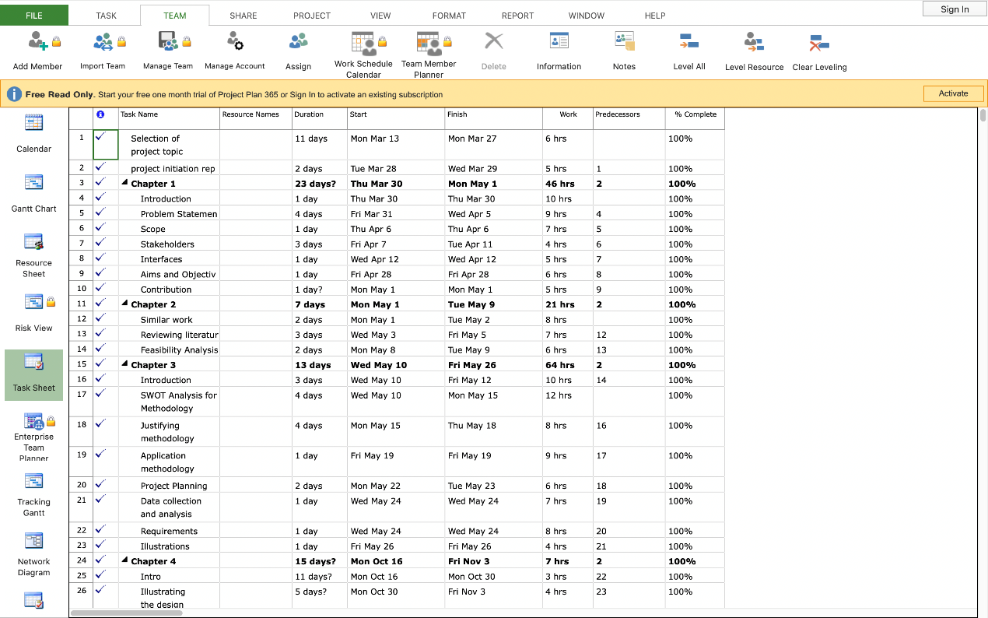

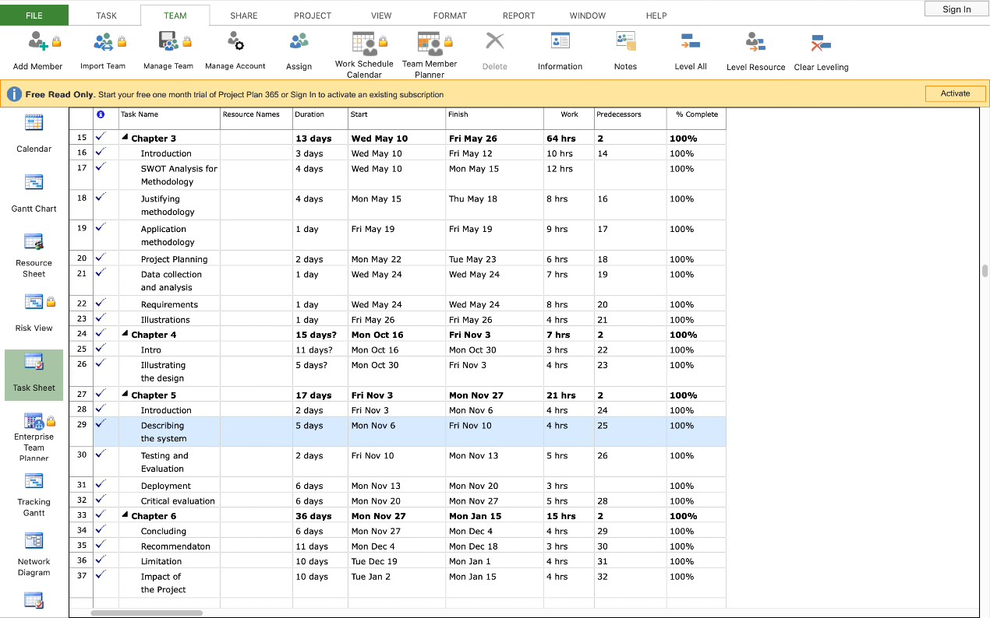

**Gantt chart:**

In addition to monitoring the development of projects, Gantt charts are a tool for project management and their scheduling. This project management tool provides for the scheduling of team collaboration, the identification and allocation of resources of any kind, and the assignment of tasks to staff. As each task is a project, the horizontal bar chart is a Gantt chart representing tasks and deadlines, beginning, and ending. As Gantt charts help project managers to view and measure their projects, they are one of Project Management's best performing tools.

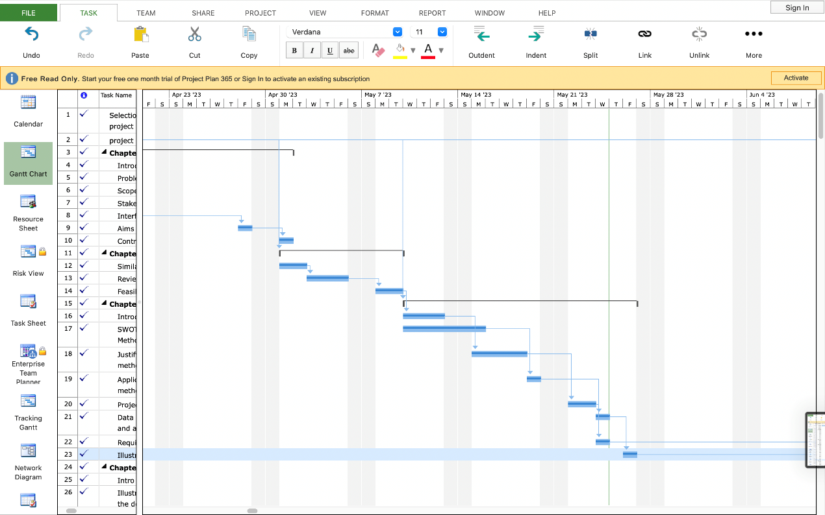

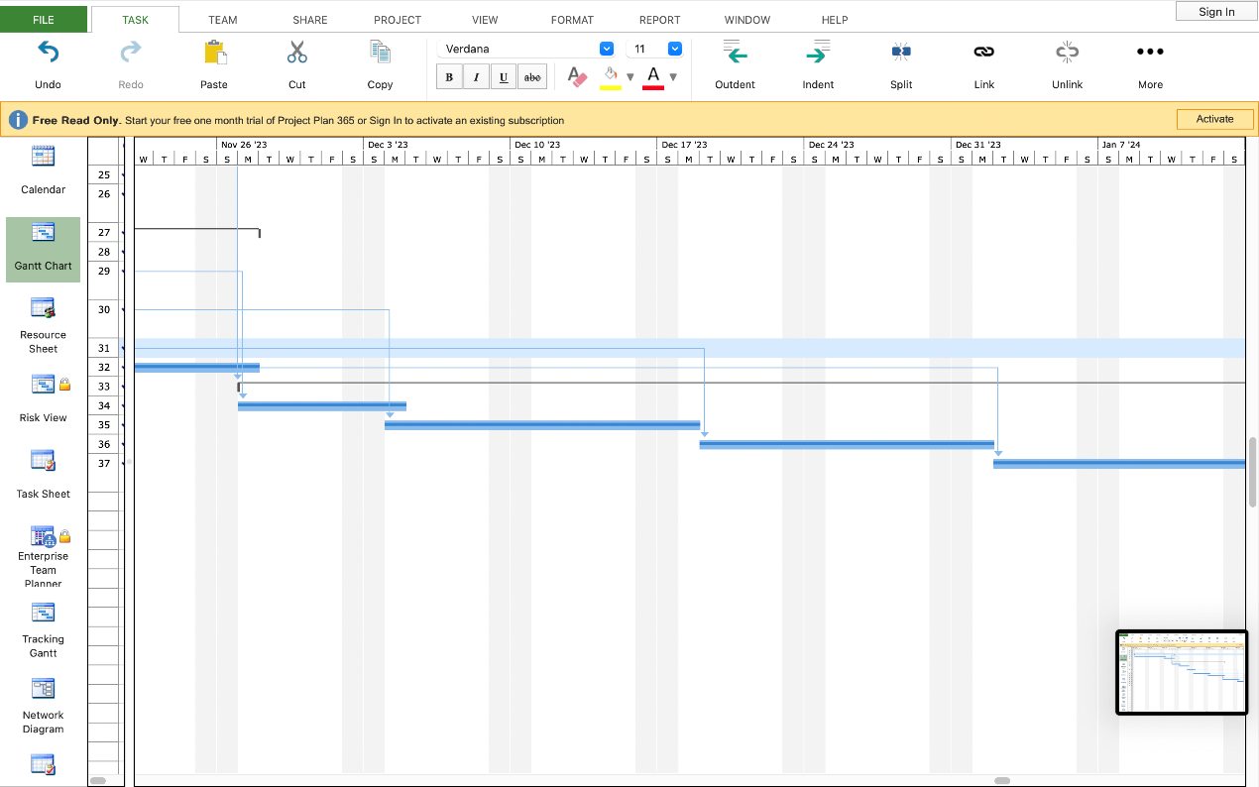

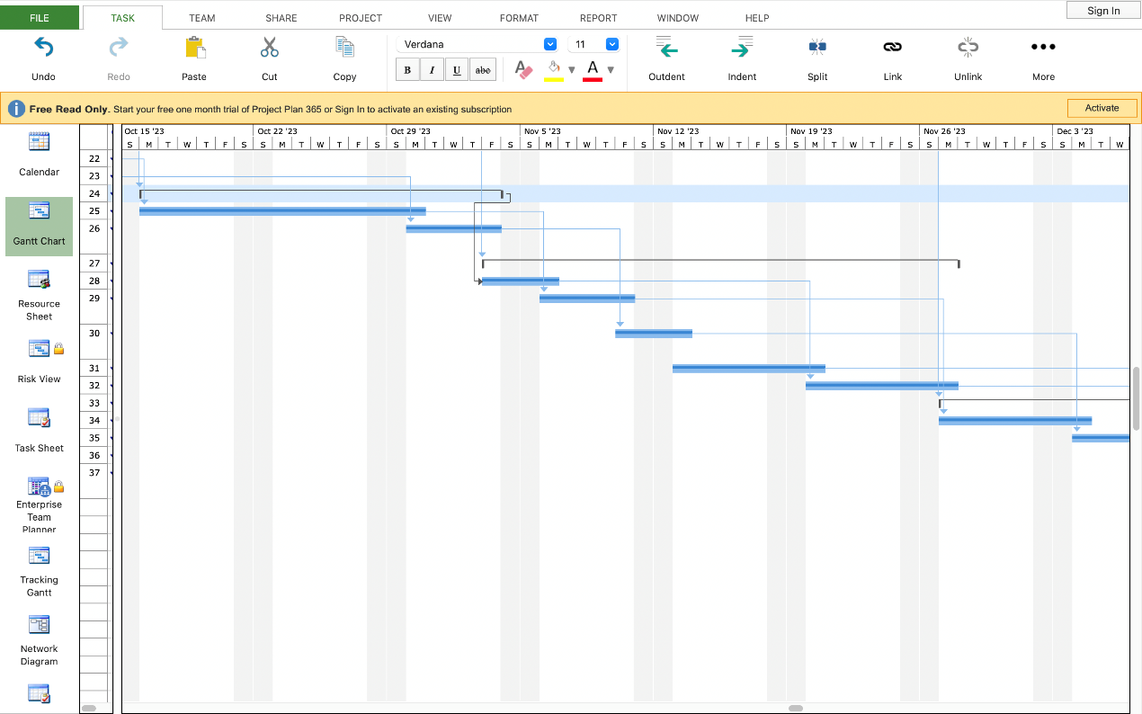

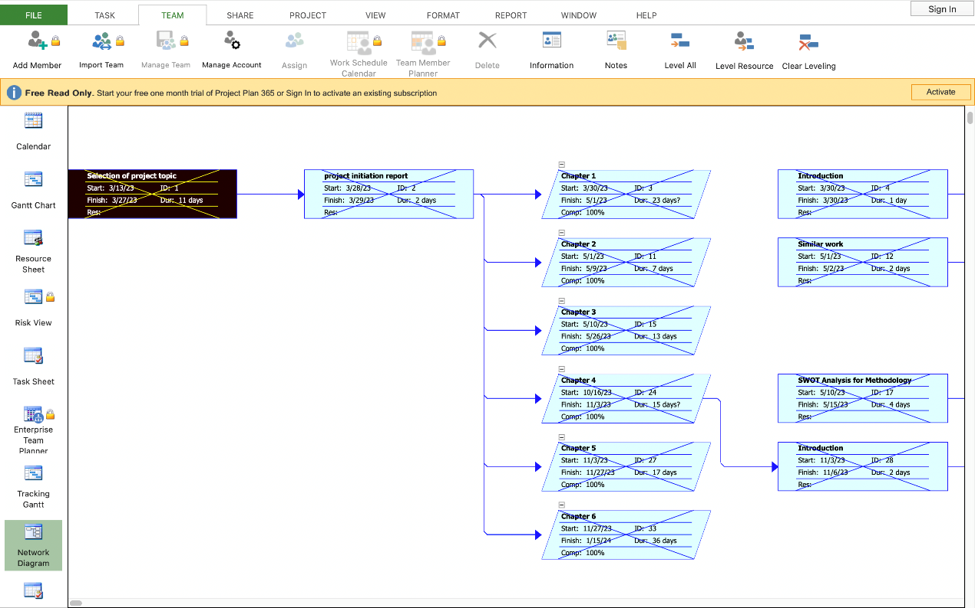

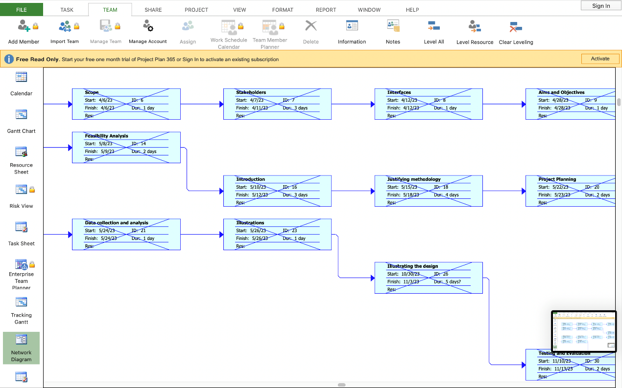

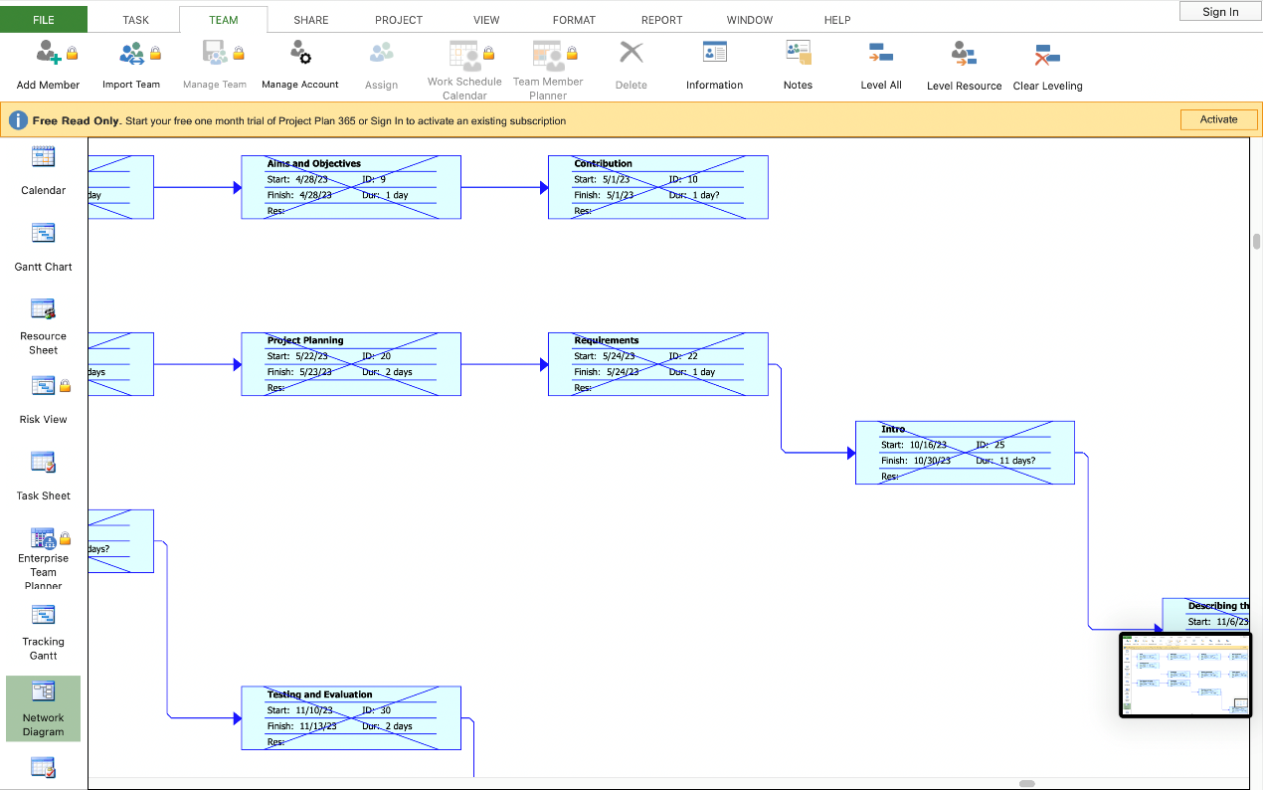

**Communication plan:**

One of the most important components of any business project is communication planning, which arranges the means and channels of communication amongst the project's stakeholders. The plan for communication includes organizing and providing stakeholders with the most recent information, as well as outlining the methods of communication that connect people. Communication planning also allows for the measurement of the impact on the project's target audience.

|  |  |  |  |  |
| --- | --- | --- | --- | --- |
| No | frequency | Participants | channel | objectives |
| 1 | One to two times weekly | Me and supervisor | Face by face at college | * Discuss the progress of the project. * Get feedback. |
| 2 | Once a month | Me and Nutritionist | Face by face at hospital | * Give advice on the right food to eat, how much sugar to consume each day, and the ideal weight. |
| 3 | One to two times monthly | Me and general public | Face by face | * Get an idea about their need to donate blood and help others, and their opinion about the site’s benefit to them in the future. |

**Risk management plan**

In addition to identifying ways to prevent risks and address them should they arise; excellent planning and documentation also identify ways to handle risks that may arise as project operations move forward. This is referred to as the "risk mitigation" strategy in risk planning. One of the most crucial arrangements that prevent potential risks is taking the appropriate precautions, along with identifying risks in advance and coming up with strategies to address them.

|  |  |  |  |  |  |  |
| --- | --- | --- | --- | --- | --- | --- |
|  | **Category/**  **Factor** | **Identified risk** | **Risk rating** | **Priority** | **Impact** | **Mitigation plan** |
| 1 | Donation Process | inadequate health record confirmation | High | High | Delay or rejection of donation | * Establish a thorough verification procedure before taking donations. |
| 2 | Medicine Information | Insufficient or incorrect drugs data | Low | Low | Wrong explanation of medicine | * The drug database should be updated and checked regularly, and users should be encouraged to contribute. |
| 3 | Hospital Location | The information in the hospital is incorrect or outdated. | Medium | Medium | Having trouble getting to the hospital. | * Frequently confirm and upgrade hospital data, client input for rectifications |
| 4 | User Awareness | There is a lack of involvement in the weekly newsletter | Low | Low | Diminished effect of consciousness | * Update the content, receive user input and add newsletter features to suit their needs |

**Resource Plan:**

In project management, resources are any kind of support that goes toward achieving the project's goals. Given that resources are everything that can be used to finish a project and meet its goals, they take up space in the project and add to its time and expense.

|  |  |  |  |  |
| --- | --- | --- | --- | --- |
|  | **Type of resource** | **Resource name** | **Quantity** | **Uses** |
| **1** | Hardware | * Computer * Printer * Mobile Phone | * One each | * Application programming * Creating documentation on website maintenance and leadership * Storing databases, other web apps, and the website |
| **2** | Software | * Internet * Teams’ app * Programming tool * Database | * One each | * Receive, send data. * Application programming * Communication |
| **3** | Human | * Web developer * Healthcare experts | * One or two for each. | * Creation and maintenance of web pages. * Supplying precise medicine guidance and information. |

**Acceptance Plan:**

A software product's "acceptance plan" is a set of specifications that it must fulfill in order for clients, customers, or users to approve it. They highlight the users' perspective and are distinct for every user story. In actuality, an acceptance criteria plan is a contract that outlines the conditions that must be fulfilled by the product in order to win final approval from your client.

|  |  |  |  |
| --- | --- | --- | --- |
| **NO** | **Deliverable** | **Criteria** | **Standards** |
| 1 | Client interface | displaying the required data while accepting user input and data | The user interface should be collaborative in order to minimise the number of presses required for each task. |
| 2 | Locating the user | In order to maintain the user's permission, confidentiality, security, accessibility, scalability, reliability, and compliance with the laws and regulations, the system must be able to precisely identify the user's location within a reasonable period of time. | Adhere to relevant area information requirements and benchmarks. |
| 3 | Project details | composing all report | All information that could be useful shall be fully documented in the project. |

**M6. step 2: Justifying data collection method**

**Data collection and analysis**

The processes involved in data collection are gathering specific information from multiple sources, analyzing and assessing it, and drawing conclusions from it to provide information useful in problem solving and plan-fulfilling outcomes. In addition to the assessment of expected outcomes through data collection operations. All processes which are included in the name of data collection shall be capable of obtaining, analyzing and measuring precise data.

Primary Data Collection Methods:

1. Questionnaires: You'll make surveys to gather data from your target audience, counting blood donors, those in need of restorative gear, and individuals searching for data about pharmaceuticals. The surveys may inquire about inclinations, statistic data, buyer comments, and specific requests that the respondents need and want.
2. Interviews: You'll be able to make surveys to gather data from your target audience, counting blood donors, those in need of therapeutic gear, and individuals searching for data about pharmaceuticals. The surveys may inquire approximately about inclinations, statistic data, shopper comments, and specific requests about the respondents' needs and want.
3. Site Visits and Observations: Visit healing centres, clinics, and other healthcare facilities to observe the strategies, comprehend the needs for restorative hardware, and assess the environment. This will offer invaluable first-hand information about the troubles experienced and potential areas for improvement.

Secondary Data Collection Methods:

1. Literature Review: Conduct an intensive examination of the accessible writing, scholarly papers, reports, and related investigations concerning blood gift drives, restorative gear accessibility, medicine data, dietary proposals, and client mindfulness. This will broaden your understanding of the issue, point out best practices, and direct the creation of my venture.
2. Document Analysis: Examine pertinent documents, including therapeutic regulations, governmental regulations, market research studies, instructional guides for healthy eating, blood donation, and the giving of medicine equipment. These documents can offer insightful information about rules, criteria, and suggestions.
3. Online Sources: To get information and actualities on blood donation, therapeutic hardware, medication data, and dietary suggestions, utilize online assets such as dependable websites, and restorative databases, inquire about articles, and attend well-being gatherings. Online assets can offer current information and user-generated substance that can advance the precision and pertinence of my venture.

It is pivotal to think about the ethical suggestions for information collection, securing member security, and maintaining secrecy. The legitimacy and unwavering quality of the information accumulated will be moved forward by cautious arrangement and the utilization of the proper inquiry methods, which can eventually increase the project's viability.

(*Research Guides: Public Health Research Guide: Primary & Secondary Data Definitions*, n.d.)

**Justifying data collection method**

I decided to use a survey to gather data for this project because of its advantages in terms of data collection and its quality when examining the questionnaire and deriving the project's requirements. The data on the questionnaire is divided into two primary categories: quantitative and qualitative. This further subdivides the questionnaire into two additional categories: structured and unstructured questionnaires. There are numerous advantages that make using the questionnaire as the primary method of gathering primary sources necessary, but the following are the most significant**:**

* + The audience's capacity to view the same questions on a large screen.
  + It's a cheap method of getting in front of lots of people.
  + The response is given clearly in exchange for neither interviews nor interview arrangements.
  + There's enough time for the audience to provide a clear response.

Through these highlights, it is conceivable to reach tall exactness in knowing the open supposition on a point. Where the target section more often than not interatomic with the survey agreeing to the introduction of the survey and the target fragment in case, they concur to fill out the survey. (Aryal, 2022)

**This is the questionnaire that was sent to people.**

**This is the link:**

[**https://docs.google.com/forms/d/1gZcDxI1nEJwXcuOLshlc8TMsK3pAce_-Thsq3j6ruPs/edit?pli=1**](https://docs.google.com/forms/d/1gZcDxI1nEJwXcuOLshlc8TMsK3pAce_-Thsq3j6ruPs/edit?pli=1)

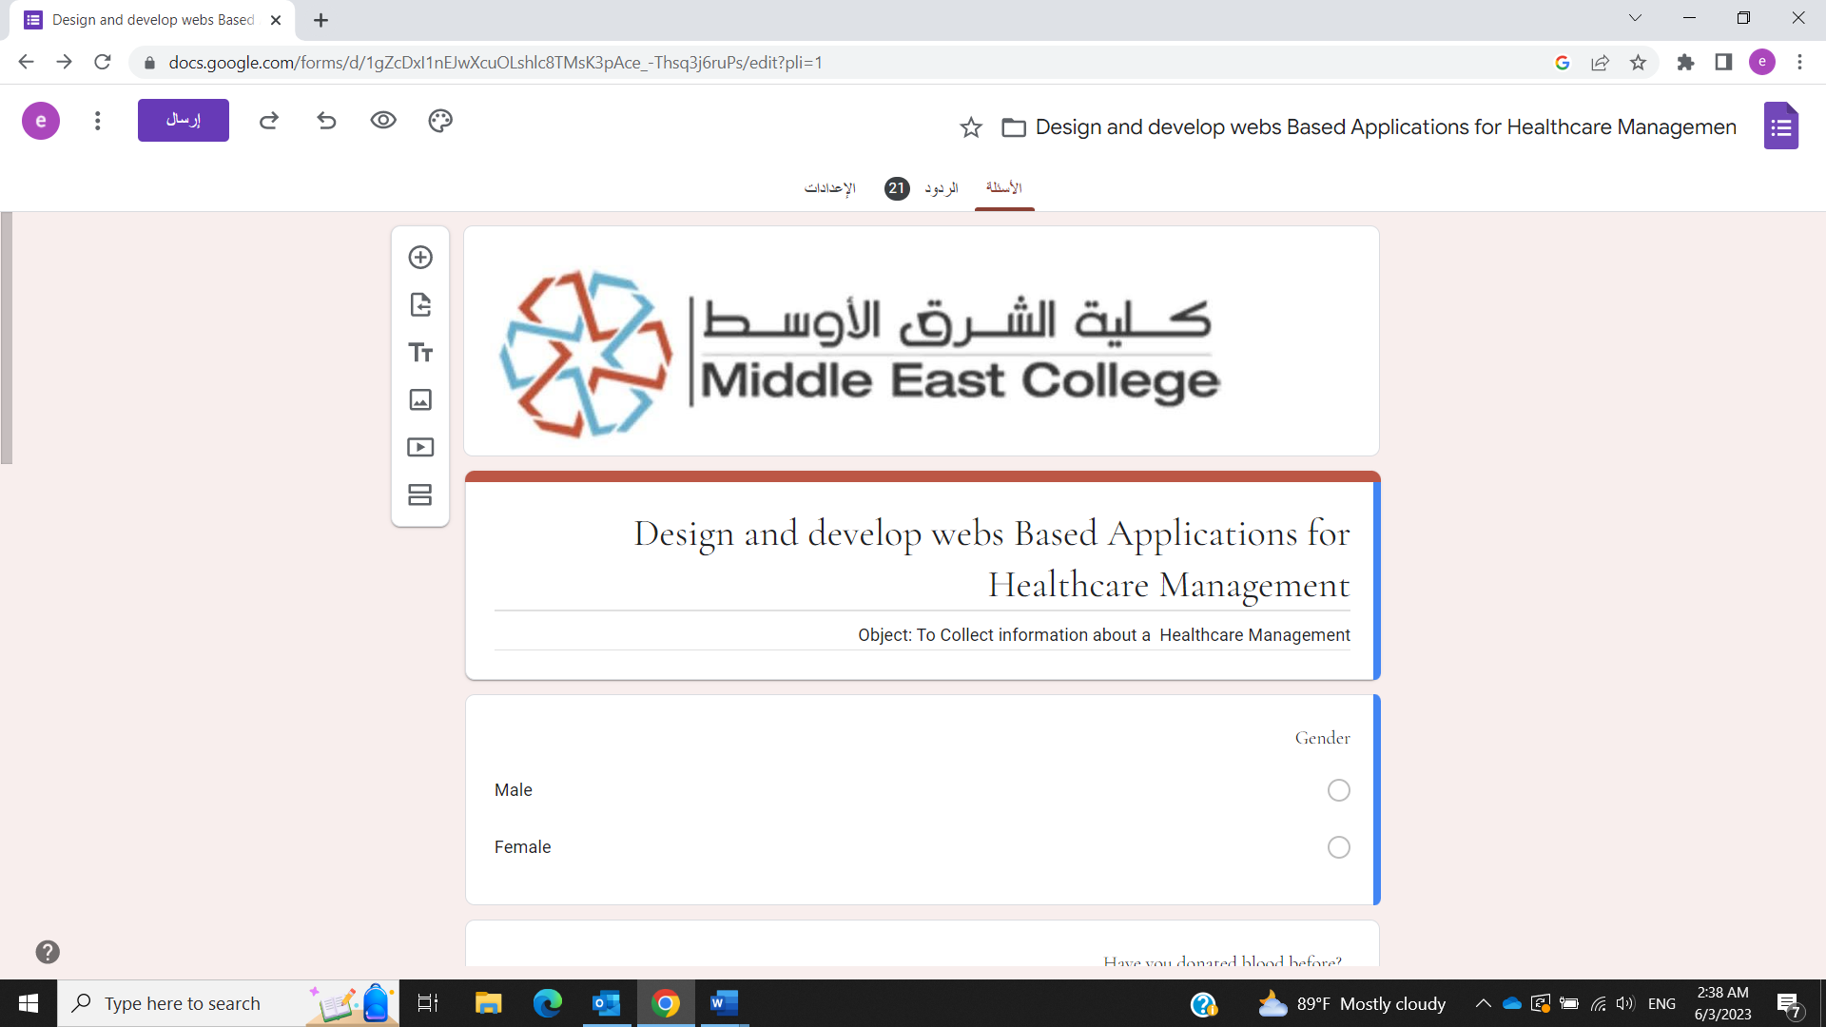

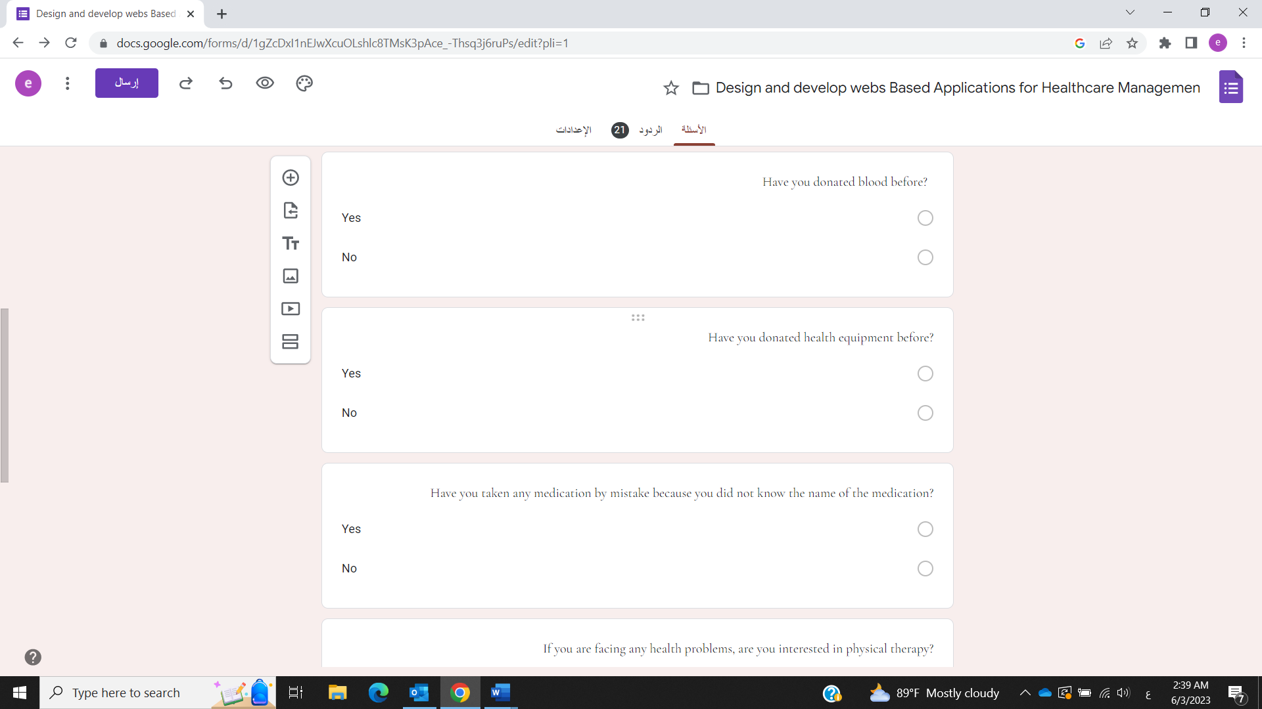

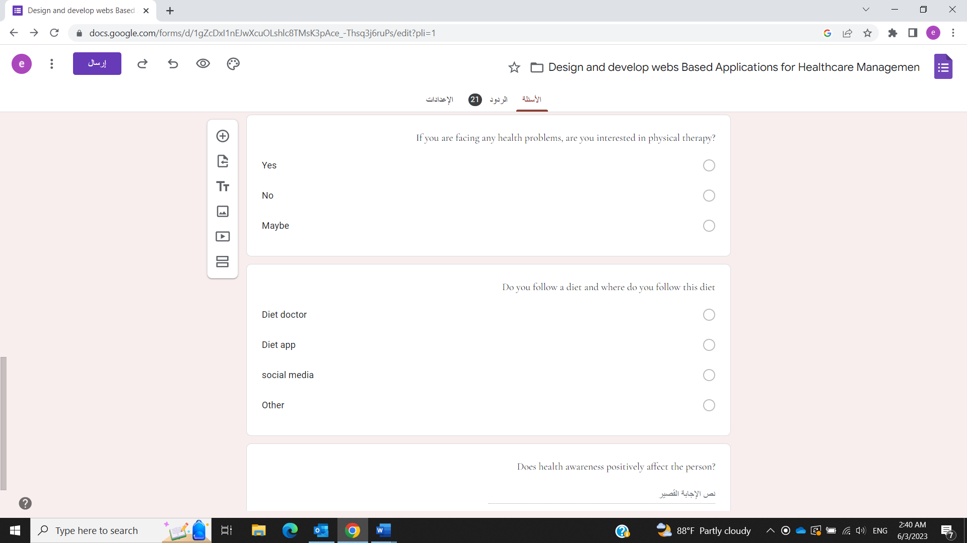

**Analysis collected data:**

Through the questionnaire that I conducted; I noticed that the group of females who donated blood was larger than the males who had previously donated blood. There were also a small number of those who donated medicine supplies. This is a very unfortunate thing, but the website that I made will help improve and increase this type of donation. In addition, there were a good number of people who took the wrong medications because they did not read the type of medication and what it was used for, which is not a very good thing, of course. There was also a large percentage of those who supported that when they face a medicine problem, they resort to physical treatments. There was also an average percentage of males and females who followed diets, some of whom were through doctors and some of them through applications or social media.

Finally, everyone answered yes to my question as to whether health awareness brings a positive benefit to the individual or not.

**M7: Requirements**:

**Describing the various requirements to develop the system.**

Several requirements must be considered when developing the project system. Aspects such as external interface, functional requirements, performance, database, security, maintainability, and usability are just a few of the categories that these requirements can be divided into. The descriptions of each requirement category are as follows:

1. **External Interface Requirements:**

• User Experience: The project needs to have a user-friendly interface that makes it simple for users to access characteristics, move among parts, and complete tasks.

• Mobile Responsiveness: The project should be responsive and optimized for many devices, including PCs, tablets, and mobile phones, to provide a consistent user experience across numerous platforms.

• Connection: The project may require interaction with external systems or APIs to access data like workout databases, dietary recommendations, or authentication for user services.

1. **Functional Requirements:**

* Verification of Users and User Signup: To use the services of the website, users must be able to register for an account and log in.

User authentication should guarantee safe access to private data and shield it from unauthorized manipulation.

* Health-related Material Donation: those should be able to give wheelchairs and other medicine equipment to hospitals or those who need it.

A form or other method for users to enter details about the equipment they wish to give should be made available on the website. By requesting sealed medicine records from the hospital or other healthcare providers, the website should be able to confirm the need for medicine equipment.

* Hospital Finder: Users ought to be allowed to use their location to search for hospitals in Muscat. Users should be given guidelines or a map on the website to help them find the closest hospital to them.

1. **Performance Requirements:**

• Responsiveness: The project should respond rapidly in order to build a user interface that is simple to use and to reduce loading and handling times for requests from users.

• Scalability: Without sacrificing speed, the system must be able to accommodate an expanding user population and a higher volume of data.

• Simultaneous Users: The project should be able to support numerous concurrent users without degrading efficiency, ensuring that users can access the system without experiencing any delays or interruptions.

1. **Database Requirements:**

• Normalization: Application of standardization strategies will enable effective and well-organized data storage. To prevent data anomalies, normalize your database schema by removing duplication and making sure that each piece of data is recorded in the right table.

• Data Migration and Integration: Create a plan for transferring data to the new database and integrating it. To ensure a smooth data migration without loss or fraud, define the processes for data visualization, alteration, and reloading.

• Data Backup and Recovery: To safeguard against data loss or system failures, establish frequent backup practices. Depending on your needs, adopt backup solutions including complete backups, incremental backups, or snapshots. To guarantee that data can be successfully restored, if necessary, test the data restoration procedure.

1. **Security Requirements:**

• User Authentication: Put in place a safe user authentication procedure to guarantee that only people with permission can access the website and its services. Username/password authentication, two-factor authentication, or interaction with external authentication service providers are some examples of this.

• Data Privacy: When managing critical or private data, use privacy controls and acquire the necessary permission.

• Regular Security Audits: Perform periodic penetration tests and security audits to find weaknesses and make sure the website is resilient to future threats. To find and quickly fix any systemic problems, conduct assessments of security.

1. **Maintainability Requirements:**

* Automated Testing: Execute computerized testing strategies such as unit testing, integration testing, and relapse testing. This permits fast, recognizable proof of issues and guarantees that changes or overhauls to the codebase don't present unintended side impacts.
* Code Documentation: Archive the codebase completely, counting comments, inline documentation, and high-level documentation. This makes a difference in how future designers understand the codebase, its reasons, and how distinctive components relate to each other.

* Version Control: Utilize a modification management framework such as Git to track changes made to the codebase. This permits simple communication among engineers, promotes rollback to earlier forms if they are vital, and guarantees a well-documented history of alterations.

1. **Usability Requirements:**

* Intuitive and User-friendly interface: Plan a clean and instinctive client interface that's simple to explore and get. Utilize clear names, fitting visual prompts, and coherent organization of substance to guarantee clients can effectively discover what they are searching for.
* Accessibility Considerations: This incorporates giving elective content for pictures, utilizing fitting colour differentiation, and empowering the console route.
* Efficient task completion: Optimize the client stream and minimize the number of steps required to complete assignments. Streamline forms and dispose of pointless client activities to improve effectiveness and decrease client disappointment.

**Tabulating information:**

**Table: System Requirements**

|  |  |
| --- | --- |
| **Requirement Category** | **Requirement Description** |
| External Interface | * 1. User Experience: a user-friendly interface.   2. Mobile Responsiveness: responsive and optimized for many devices.   3. Connection: APIs to access. |
| Functional Requirements | 1. Verification of Users and User Signup: able to register for an account and log in. 2. Health-related Material Donation: give wheelchairs and other medicine equipment. 3. Hospital Finder: Users ought to be allowed to use their location to search for hospitals in Muscat. |
| Performance Requirements | 1. Responsiveness: respond rapidly to build a user interface. 2. Scalability: accommodate an expanding user population and a higher volume of data. 3. Simultaneous Users: support numerous concurrent users without degrading efficiency. |
| Database Requirements | 1. Normalization: enable effective and well-organized data storage. 2. Data Migration and Integration: Create a plan for transferring data. 3. Data Backup and Recovery: To safeguard against data loss or system failures. |
| Security Requirements | 1- User Authentication: Put in place a safe user authentication procedure.  2- Data Privacy: use privacy controls and acquire the necessary permission.  3- Regular Security Audits: find and quickly fix any systemic problems. |
| Maintainability Requirements | 1. Automated Testing: Execute computerized testing strategies such as unit testing. 2. Code Documentation: Archive the codebase completely. 3. Version Control: Utilize a modification management framework. |
| Usability Requirements | 1. Intuitive and User-friendly interface: Plan a clean and instinctive client interface that's simple to explore and get. 2. Accessibility Considerations: This incorporates giving elective content. 3. Efficient task completion: Optimize the client stream and minimize the number of steps. |

**M8: Illustrations:**

**Use case diagram:**

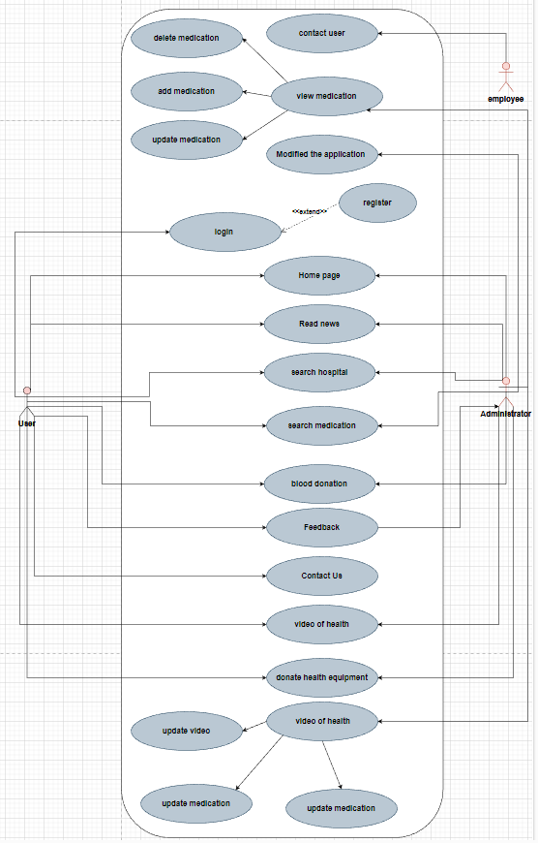

**Context Diagram Level 0.0**:

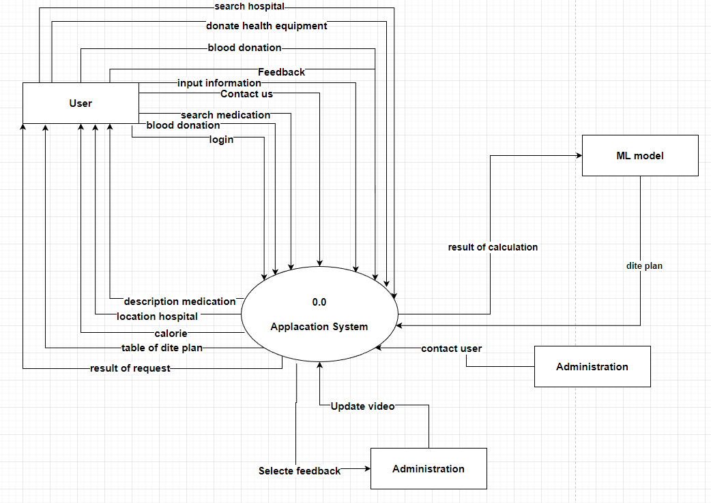

**Context Diagram Level 0.1**

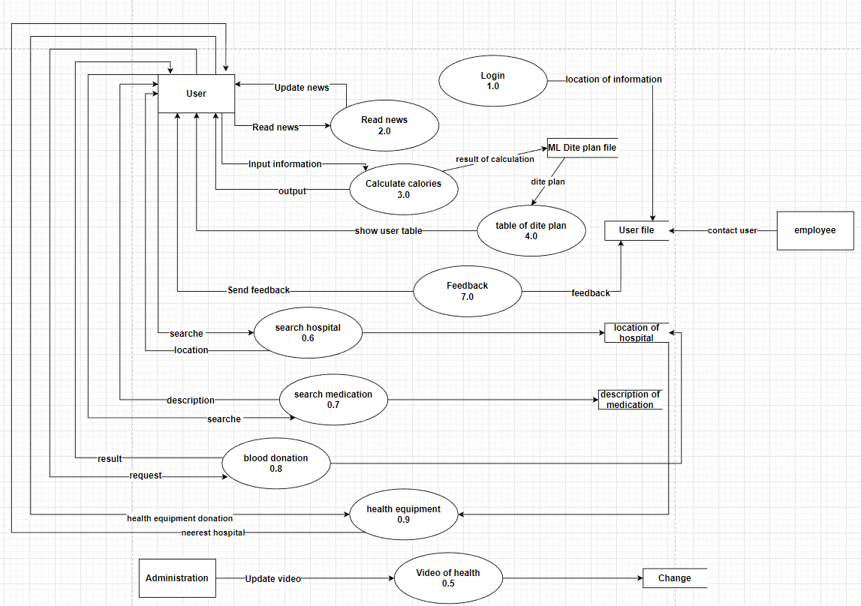

**flow chart:**

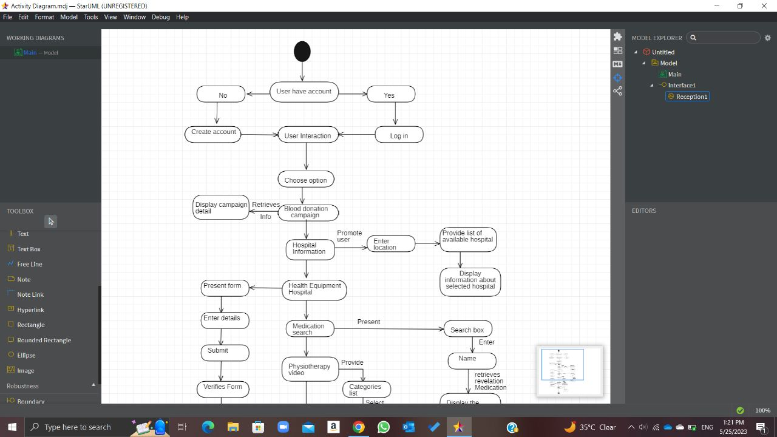

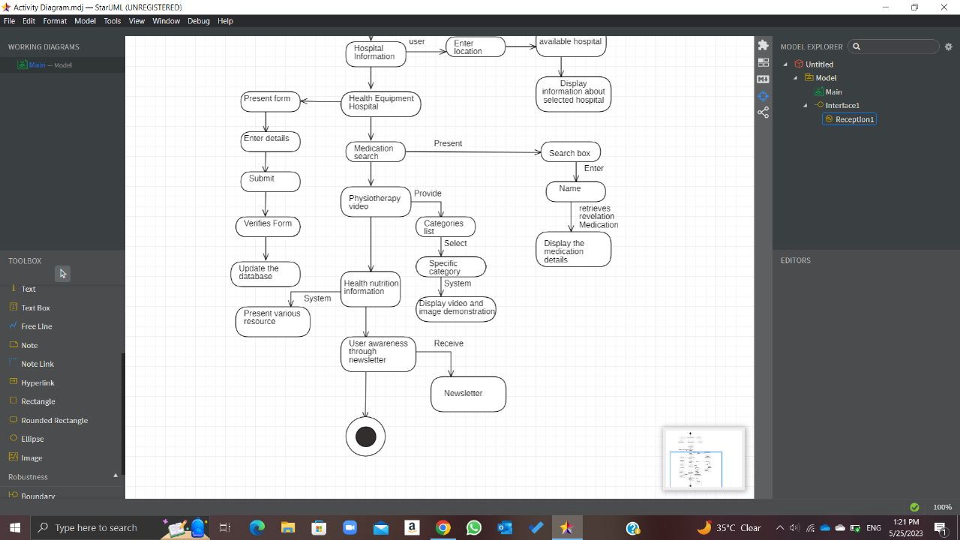

**ERD:**

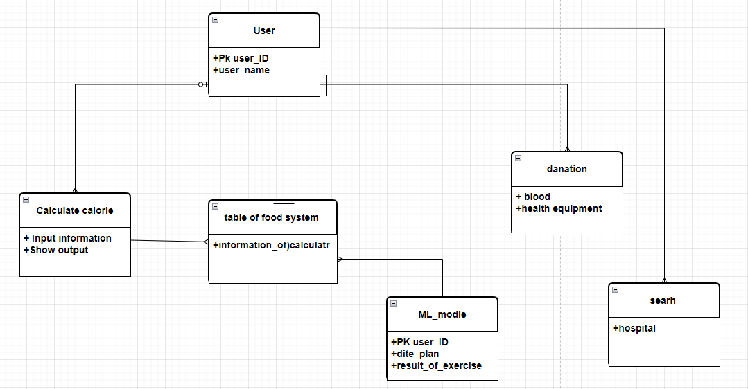

**Application:**

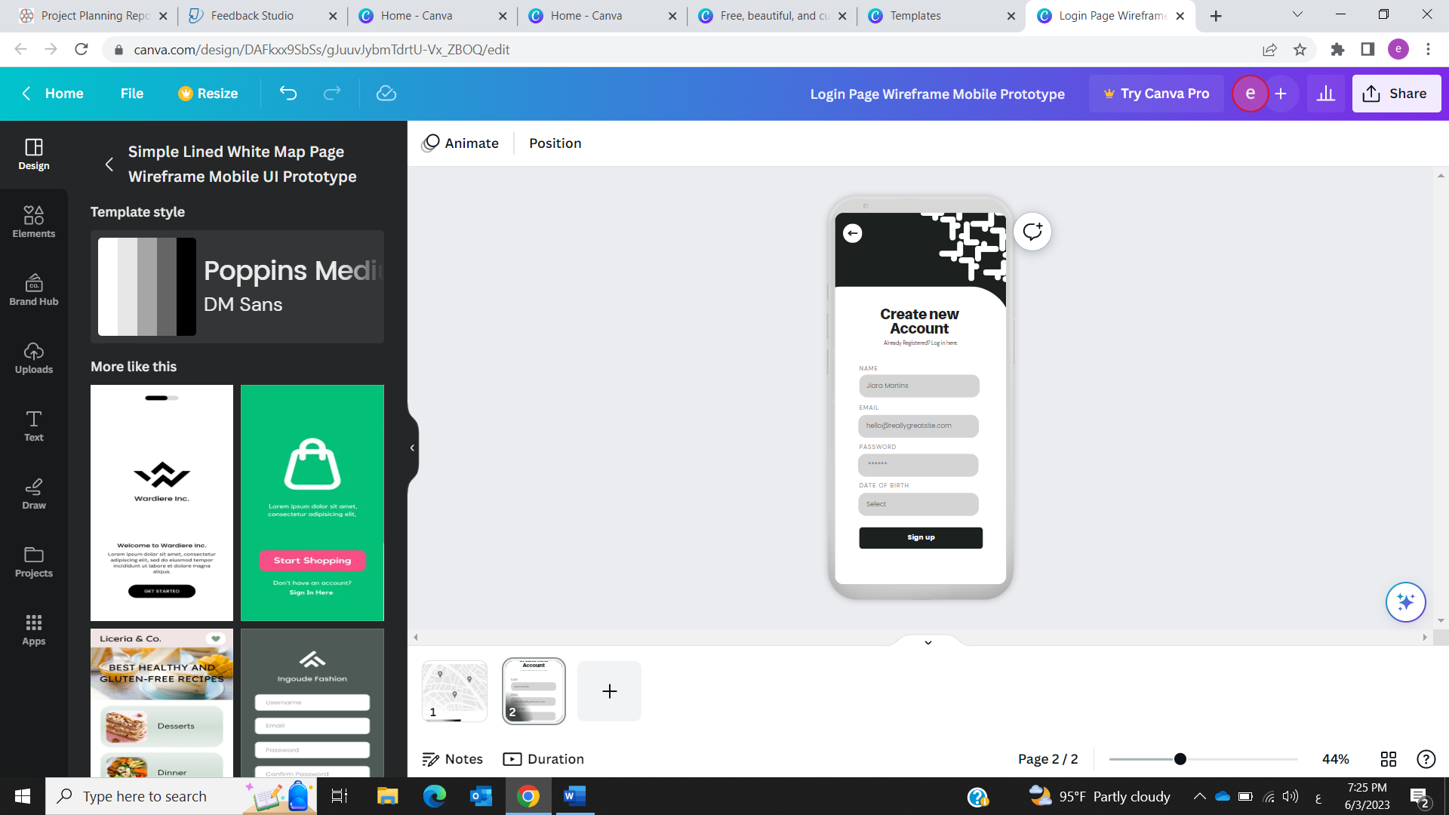

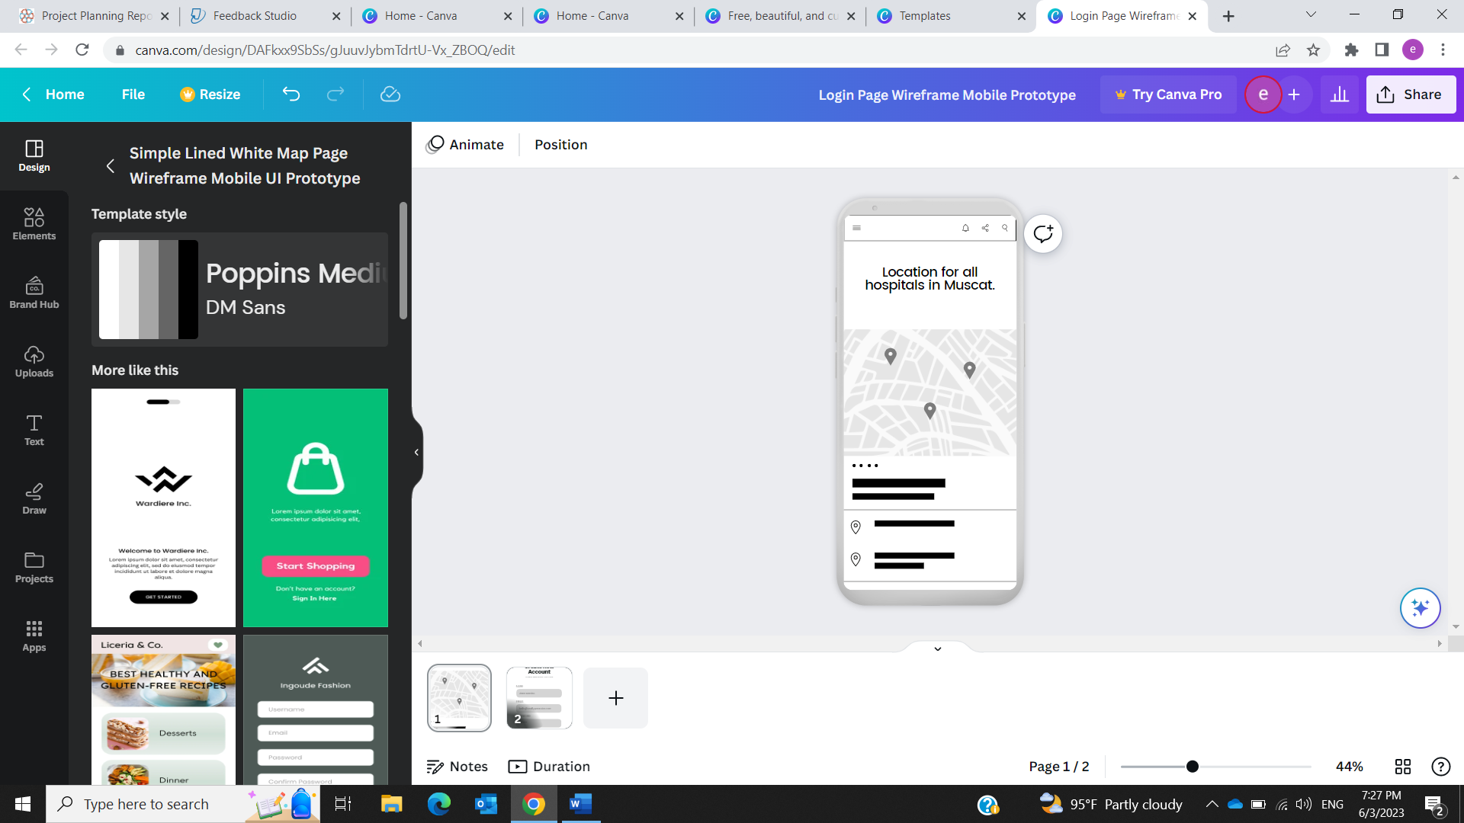

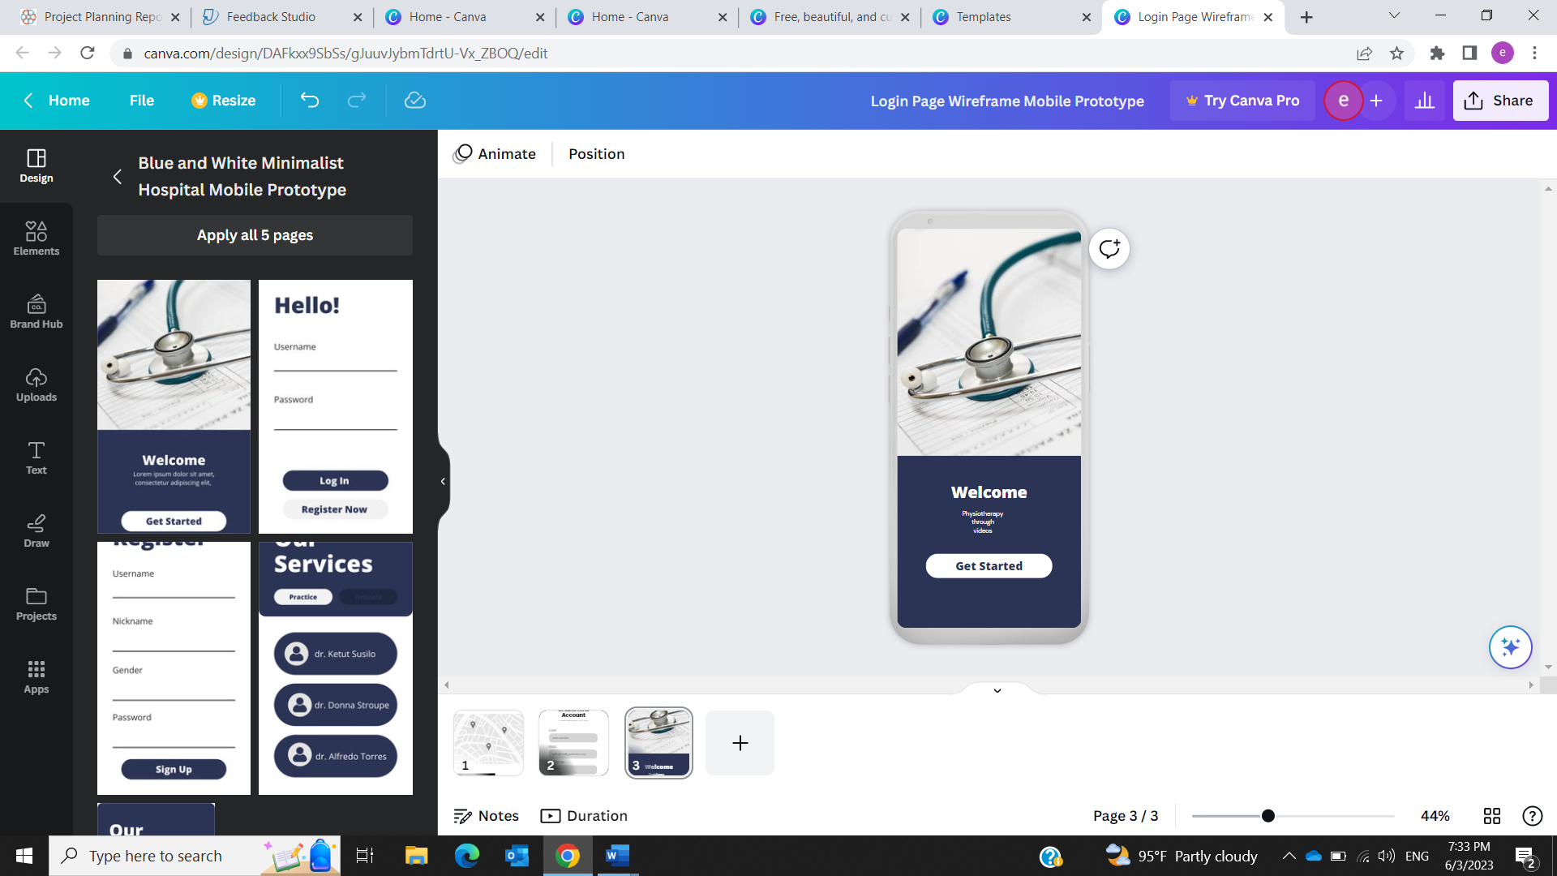

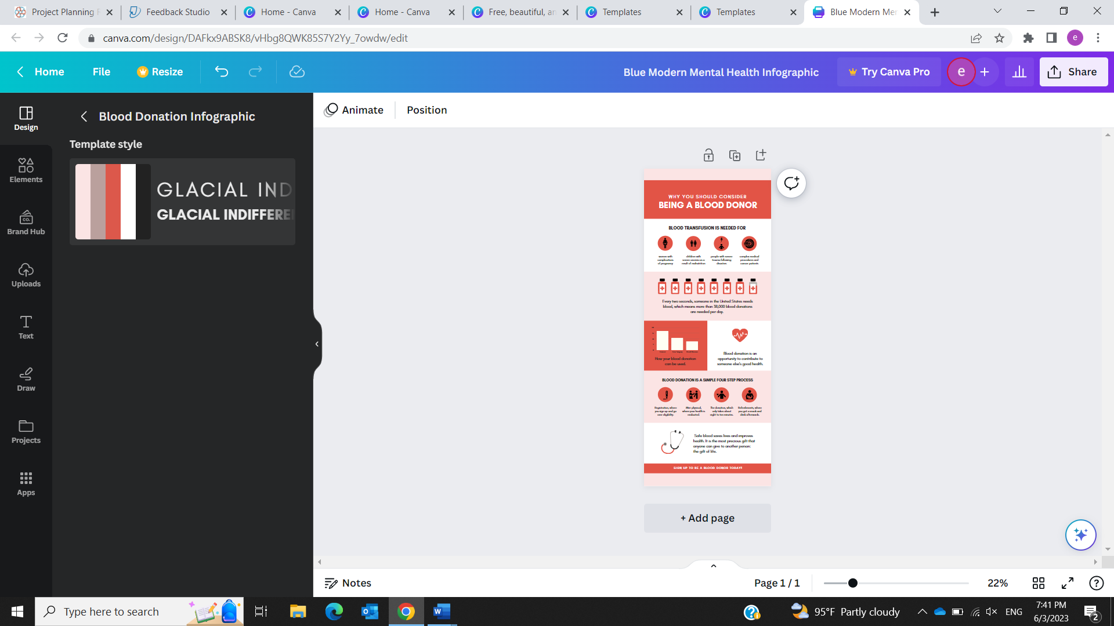

**Reference:**

* Astrup, A. (2001). Healthy lifestyles in Europe: prevention of obesity and type II diabetes by diet and physical activity. Public Health Nutrition, 4(2b), 499–515. <https://doi.org/10.1079/phn2001136>
* Atlassian. (n.d.). *What is Agile? | Atlassian*. <https://www.atlassian.com/agile#:~:text=The%20Agile%20methodology%20is%20a,planning%2C%20executing%2C%20and%20evaluating>.
* *Figure 2. The healthline visualises personal fitness and biomarker data*. (n.d.-b). ResearchGate. <https://www.researchgate.net/figure/The-healthline-visualises-personal-fitness-and-biomarker-data_fig6_303790919>
* Health, A. (2022, March 15). What is health?: Defining and preserving good health. Medical and health information <https://www.medicalnewstoday.com/articles/150999>
* Indeed Editorial Team. (2022b). What is iterative methodology and why is it useful? Indeed.com UK. <https://uk.indeed.com/career-advice/career-development/what-is-iterative-methodology#:~:text=The%20answer%20to%20'What%20is,often%20applied%20in%20other%20fields>
* Kissflow, Inc. (2023b). RAD Methodology | Rapid Application Development Phases - Kissflow. *Kissflow, Inc*. <https://kissflow.com/application-development/rad/rapid-application-development-methodology-essentials/#:~:text=RAD%20methodology%20is%20a%20way,you've%20built%20the%20software>
* Mostafa, A. M. (2014, December 23). A Framework for a Smart Social Blood Donation System Based on Mobile Cloud Computing. arXiv.org. <https://arxiv.org/abs/1412.7276>
* Monkman, H., Schmidt, T. J., & Nøhr, C. (2020). Online Medication Information for Citizens: A Comparison of Demands on eHealth Literacy. PubMed, 270, 1026–1030. <https://doi.org/10.3233/shti200317>
* Metalmark, M. B., Hunt, M. K., Heath, G. W., & Schmid, T. (1993). Realistic Outcomes: Lessons from Community-Based Research and Demonstration Programs for the Prevention of Cardiovascular Diseases. Journal of Public Health Policy, 14(4), 437. <https://doi.org/10.2307/3342877>
* *MindTools | Home*. (n.d.-b). <https://www.mindtools.com/amtbj63/swot-analysis>
* Realdon, O., Rossetto, F., Nalin, M., Baroni, I., Cabinio, M., Fioravanti, R., Saibene, F. L., Alberoni, M., Mantovani, F., Romano, M., Nemni, R., & Baglio, F. (2016). Technology-enhanced multi-domain at the home continuum of care program concerning usual care for people with cognitive impairment: the Ability-TelerehABILITation study protocol for a randomized controlled trial. BMC Psychiatry, 16(1). <https://doi.org/10.1186/s12888-016-1132-y>

*Research Guides: Public Health Research Guide: Primary & Secondary Data Definitions*. (n.d.-b). <https://researchguides.ben.edu/c.php?g=282050&p=4036581#:~:text=Primary%20data%20refers%20to%20the,collected%20by%20someone%20else%20earlier.&text=Surveys%2C%20observations%2C%20experiments%2C%20questionnaire,journal%20articles%2C%20internal%20records%20etc>

* Team, A. C. (n.d.-c). *Waterfall Methodology: Project Management | Adobe Workfront*. <https://business.adobe.com/blog/basics/waterfall>
* Team, A. C. (n.d.-b). *Project Monitoring & Controlling Phase | Adobe Workfront*. <https://business.adobe.com/blog/basics/monitoring-controlling>
* Aryal, S. (2022, March). Questionnaire method of data collection. The Biology Notes. <https://thebiologynotes.com/questionnaire-method-of-data-collection/>
* Work Breakdown Structure (WBS): The Ultimate Guide (with Examples). (2023, March 27). ProjectManager. <https://www.projectmanager.com/guides/work-breakdown-structure#:~:text=A%20work%20breakdown%20structure%20(WBS)%20is%20a%20visual%2C%20hierarchical,required%20to%20complete%20their%20projects.>
* **Appendices:**

